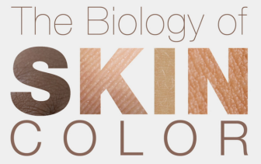
Name ________________________
Part 1 (0 – 3:54):
Can you think of other traits that are highly variable like human skin color?

What is an adaptation?

What is the connection between DNA and visible traits?

Part 2 (3:55 – 9:07):
What is a mutation?

The enzymes to produce melanin are found in all major taxa of life. What does this suggest about the importance of melanin production for living things?

Why do areas of high altitude (e.g., on the Tibetan plateau) have greater than expected UV intensity and areas of constant cloud cover (e.g., Congo Basin) have less than expected?

What does “indigenous” mean? Why is it important when sampling human skin color to know whether an individual is indigenous or not?

Part 3 (9:08 – 13:32):
Other primates have pale skin. Why isn’t this a disadvantage to primates other than humans living in areas with intense UV radiation?

What did scientists infer from the lack of variation in the MC1R gene among African populations?

Melanin protects individuals from skin cancer. What is it about the timing of skin cancers that may decrease their importance in causing the evolution of dark skin color?

Part 4 (13:33 – 18:57 End):
Darker skin protects skin cells from UV radiation. So why aren’t all humans dark skinned?

Indigenous peoples with diets rich in vitamin D living in high latitudes have dark skin. How does this observation support the hypothesis presented in the film about the selective pressure for the evolution of lighter skin? What other explanations could account for this observation?

What are the risks associated with light skin in equatorial areas? With dark skin in high latitudes?

