Name: _________________

BIOMOLECULE REVIEW

Carbohydrates  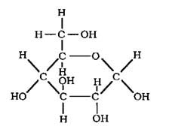 | 1. Also called the _________ group.  2. Used to provide __________for the cells of living things.  3. Found in food examples like:  4. “Single sugar” ______________________  5. “Double sugar” ______________________  6. Large sugars ______________________
Lipids  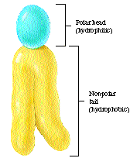 | 7. Also called the ____________ group.  8. Used to ____________ energy in animals.  9. Makes up the ___________________ of cells.  10. Three types of lipids are __________, __________, and __________.
Nucleic Acids  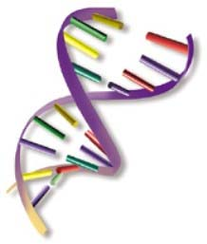 | 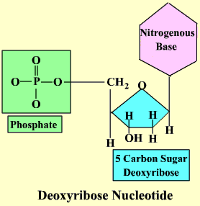  11. Carry ________________ information.  12. Made up of smaller units called _________________. (pictured here)  13. Two examples: __________ & __________
Proteins  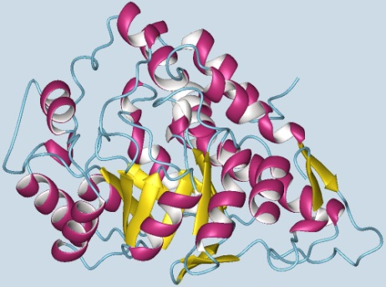 | 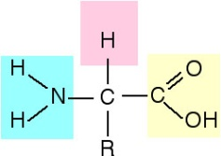  14. Made up of smaller units called _________________. (pictured here)  15. Proteins make __________ & __________.  16. Specialized proteins are called _________________ that are involved with chemical ______________________.

