**Blood Typing Practice Problems**

Name _______________________ Class ______

1. 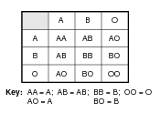Julie has blood type A and she marries Mark, whose blood type is B. They have three children: Joan, James, and Pete. Joan has blood type O, James has blood type A, and Pete has blood type B. Explain how this is possible. Show your work using a Punnett square.

[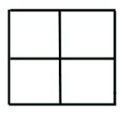](http://users.adelphia.net/~lubehawk/BioHELP!/psquare0.jpg)

What are the parent genotypes?

P:______ x ______

Explain:

1. SpongeBob decided that he wanted to donate blood at the local hospital. He has type B blood. Right after SpongeBob gives blood, a woman, SpongeBillyJean, arrives at the hospital’s emergency room after losing a lot of blood from a sea urchin spike wound. SpongeBillyJean has type AB blood.
   1. Can SpongeBob’s blood be transfused to SpongeBillyJean? Explain your answer AND use pictures of red blood cells, antigens, and antibodies.
   2. If SpongeBob and SpongeBillyJean were to start a family, what would be the possible blood types of their children? Show your work with Punnett squares.
2. A woman with type A blood is claiming that a man with type AB blood is the father of her child, who is type B. Could this man be the father of her child?

To figure this out, show all possible crosses with Punnett squares. REMEMBER…a woman who is type A blood can have the genotypes AA or AO.

Could this man be the father? *Circle one:* Yes or No

What must be the woman’s genotype? _______

1. A man with type AB blood is married to a woman with type O blood. They have two natural children and one adopted child. Jane has type A blood, Bobby has type B blood, and Grace has type O blood.

Which child was adopted? ____________________. Show your work!