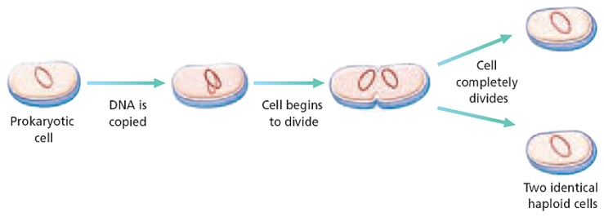
What is Cell Division?

How Do Prokaryotic Cells Reproduce?

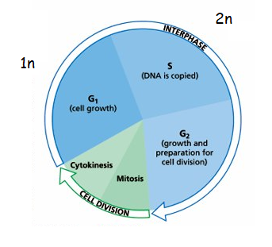
How Do Eukaryotic Cells Reproduce?

CELL CYCLE!

The Cell Cycle Consists of Two Phases – INTERPHASE AND MITOSIS

PART 1 – INTERPHASE

- Interphase =

___________ - Time when cell grows to full size

___________ - Time when cell replicates DNA

___________ - Time when cell duplicates its organelles

___________ - Time when cell leaves the cycle (Not all cells do this! – Example = nerves)

How is Cell Division Controlled???

Control Occurs at 3 Main Checkpoints  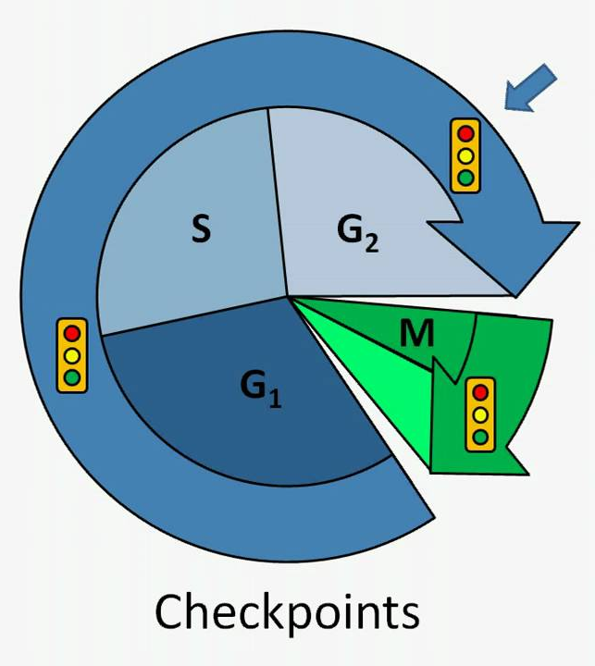 | What happens when the control is lost?

PART 2 – MITOSIS (M - Phase)
5.

The Two Parts of Mitosis
6.
The Result of Mitosis | Why Does Mitosis Happen? | How Long Does Mitosis Take?

STAGES OF MITOSIS
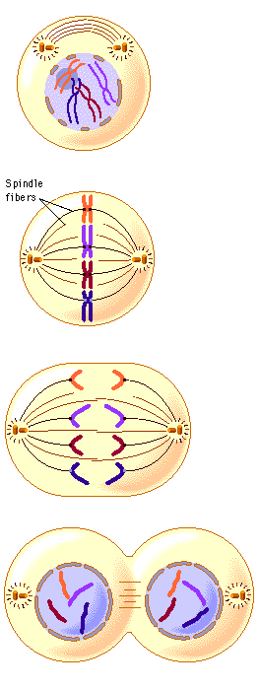
Prophase – The “Prepare” Phase

Metaphase – The “Middle” Phase

Anaphase The “Away” Phae

Telophase The “End” Phase
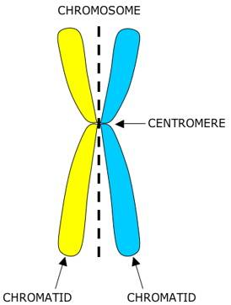

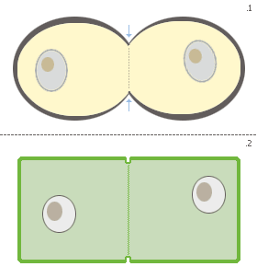
Cytokinesis – The Cytoplasm Divides in 2!

Plants | Animals

DNA Structure

Chromatin | Chromosome | Centrioles “Tow Truck” | Diploid (2n) | Haploid (1n)

