Click on the AnimalLite App on your iPad. Go to Mitosis > Study to answer the following questions.
Name:

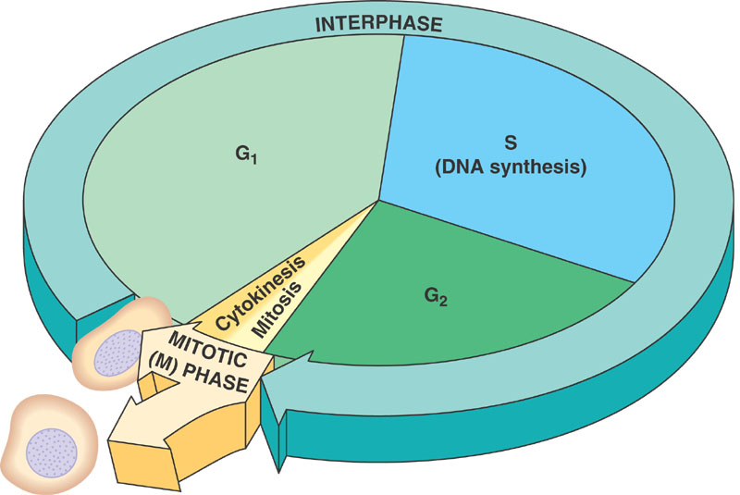
Mitosis
- Label the following image of the cell cycle:

- What occurs during the G1 phase?

- What occurs during the S phase?

- What occurs during the G2 phase?

- What is mitosis?

- What is cytokinesis, and what happens during this process?

- What does mitosis and cytokinesis result in?

- Why is this process essential for cells?

Interphase
- How does the time a cell spends in interphase compare to the time it spends in the M-phase?

- What is happening during interphase?

- How is an interphase cell distinguished from a dividing cell?

Prophase
- What happens to DNA in this phase of mitosis?

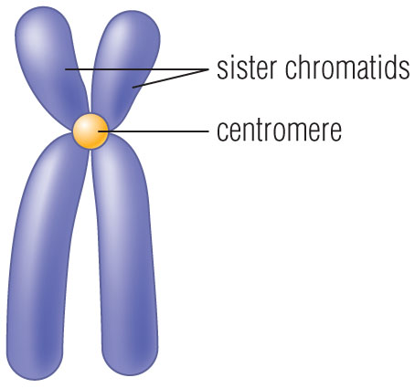
- Label the chromosome to the right with the following terms:

  - Sister chromatids
  - Centromere

- What happens to the nuclear membrane?

- What forms at opposite ends of the cell?

Metaphase
- Can we see the nuclear membrane during this phase?

- What do the microtubules attach to?

- What are the chromosomes doing?

Anaphase
- What is happening during anaphase?

- What results from this phase?

Telophase
- What begins to form in this phase?

- What happens to the chromosomes?

Cytokinesis
- What is cytokinesis?

- What is the indent that forms during cytokinesis in animal cells called?

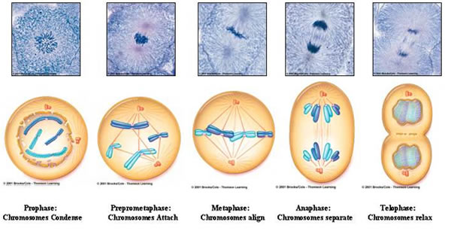
Go back to the menu and click on the practice button. Practice labeling cells by the phases they are in.

