Cell Cycle and Mitosis Vocabulary Matching

Write the letter of the correct vocabulary word with its matching definition on the line.

_______ First and longest phase of mitosis; chromatin coils into visible chromosomes; the nuclear envelope disappears; spindles form

_______ Shortest phase of mitosis; chromosomes move to the center of the cell; chromatids are attached by centromeres

_______ Centromeres split and sister chromatid are pulled apart

_______ Final phase of mitosis; nuclear envelope begins to reappear; spindles break down; chromosomes unwind

_______ The cell spends most of its time in this phase; period of growth and DNA synthesis

_______ Division of the nuclear material; two new daughter cells form identical to the parent cell

_______ Division of the cytoplasm

_______ Highly condensed form of DNA wrapped around proteins; only seen during cell division

_______ DNA is found as this loose, uncondensed state during interphase

_______ Structures found in animal cells that produce spindles; they move to opposite poles during prophase

_______ Cell structure that joins two sister chromatids of a duplicated chromosome

_______ Cell structures composed of microtubule fibers; pull apart sister chromatids during anaphase

_______ Identical halves of a duplicated chromosome; held together by a centromere

_______ Genetically identical cells; the result of cell division

- anaphase
- centriole
- centromere
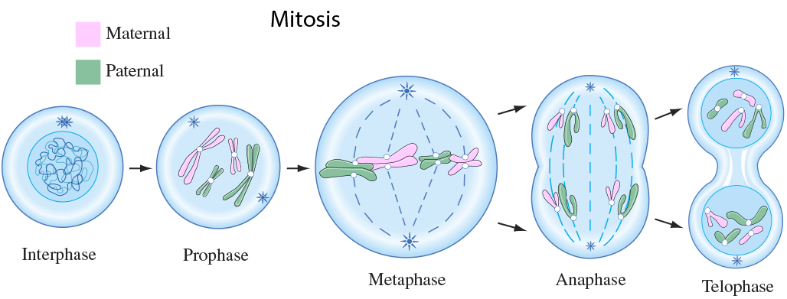
- chromatid
- chromatin
- chromosome
- cytokinesis
- daughter cells
- interphase
- metaphase
- mitosis
- prophase
- spindle
- telophase

