Cell Cycle Opener
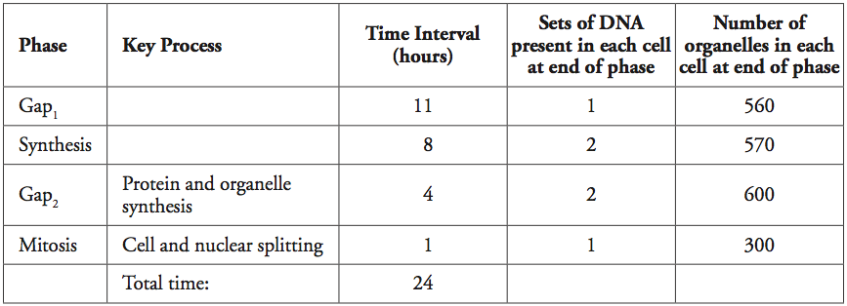

- The table above contains data for a typical human cell in culture. Use the phase names in the first column to label the G, M, and S phases in the cell cycle diagram below.
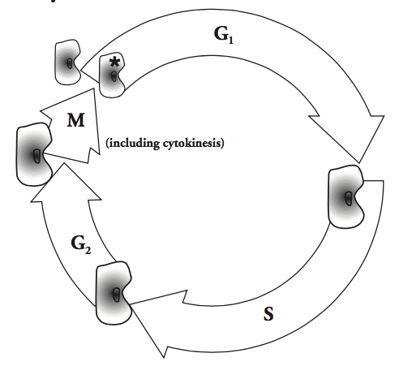

- Look at the third column in the table. Compare the time spent in mitosis with the time spent in gap₁ in human cells and describe any difference.

- Imagine 100 cells were chosen randomly from a tissue sample and examined under a microscope. In which phase of the cell cycle would you expect to find the largest number of cells? Explain.

- Look again at the table. Compare the amount of DNA at the beginning and end of synthesis. Why did the amount of DNA change?

- Fill in the “Key Process” column for gap₁ and synthesis. Use the table and cell cycle diagram for help.

- Cytokinesis means “cell cutting,” where the cytoplasm splits to form two new daughter cells at the end of mitosis. Other than cytokinesis, what else occurs during the mitosis phase? Hint: Consider the sets of DNA in each cell.

  - If a culture in the lab starts with one human cell, how many cells will there be after 24 hours?

  - The total time for the phases listed in the table is 24 hours. How many human cells will be in the culture after another 24 hours?

- Is the original cell “dead” or does it disappear after mitosis? Explain your answer.

- If a starfish sustains damage to a limb, it often grows a new one. If a human adult sustains damage to his or her spinal cord, mobility is often impaired. If a gecko loses its tail, it may grow a new one. Which type of cell is less likely to go through the cell cycle after being damaged—starfish limb, human spinal cord, or gecko tail? Support your answer.

- Cancer, the uncontrolled growth of cells, often results in a tumor, or mass of abnormal cells. Some cancerous tumors consist of many cells that are much smaller than normal. According to the cell cycle diagram, what part(s) of the cell cycle is (are) most likely being affected?

