Actively Dividing Cells

Part A: Cheek Cells
Procedure:
- Obtain slide, cover slip, & tooth pick
- Put a small drop of NaCl solution on slide
- Gently rub toothpick along inside of cheek
- Roll cheek side of toothpick in NaCl solution on slide
- Add 1 drop of methylene blue to your cells
- Put cover slip on and find your cells under the microscope!!

In the space below draw your cells under each magnification:

10x (red) 50x (yellow) 100x (blue)

When observing your cheek cells, what phase in the cell cycle do you see the most of?
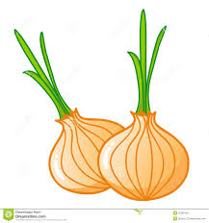

Part B: Onion Root Tip

The tip of onion roots are always dividing. Please identify and draw the
following phases in your onion root tip slide.

Interphase Prophase Metaphase

Anaphase Telophase Cytokinesis

What phase are most of the cells in? ________________________________________________

