Name: \_\_\_\_\_\_\_\_\_\_\_\_\_\_\_\_\_\_\_\_\_\_\_

**Cladograms**

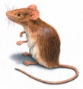

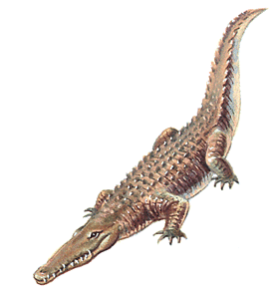

C:\Documents and Settings\mprosise\Local Settings\Temporary Internet Files\Content.IE5\CQBKZKFX\MCj04125000000[1].wmfC:\Documents and Settings\mprosise\Local Settings\Temporary Internet Files\Content.IE5\L99MUDXC\MCAN00465_0000[1].wmf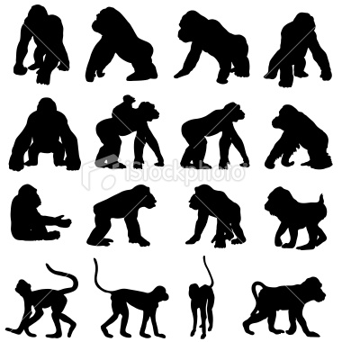

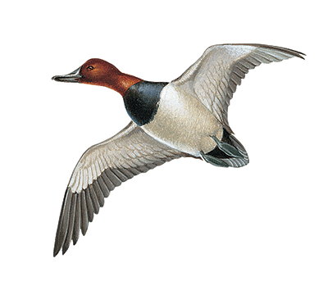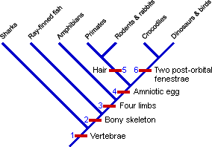

C:\Documents and Settings\mprosise\Local Settings\Temporary Internet Files\Content.IE5\Q1WE6MB2\MCAN02328_0000[1].wmf

1. Cladograms display evolutionary relationships by grouping living things based on common characteristics. We have also created cladograms based upon biological molecules and how many proteins animals have had in common. The cladogram above has grouped animals based upon \_\_\_\_\_\_\_\_\_\_\_\_\_\_\_\_\_\_\_\_\_\_\_\_\_\_\_\_\_\_\_\_.

2. Which animals in the above cladogram are considered Vertebrates?

3. Which animal(s) in the cladogram above have four limbs?

4. Which are the only animal(s) in the cladogram above that have body hair?

5. Which is the only animal(s) in the cladogram above that does not have a bony skeleton?

6. Which 2 groups of animals are more closely related and why?

7. Which group of animals is least closely related to all others and why?