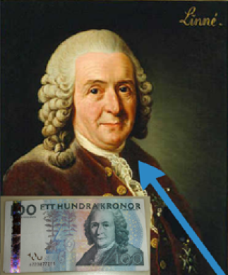
OLD SCHOOL:
Carl Linnaeus
2 contributions:

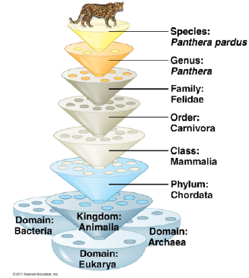
Name 3 domains and how
they’re organized

What was old system like?

What is current model?
(Life’s Major Divisions)

NEW SCHOOL:
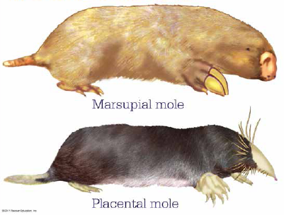
What were 2 main issues
with old system?

How has DNA revolutionized
classification?

How can we use the rate of
mutation in genes?
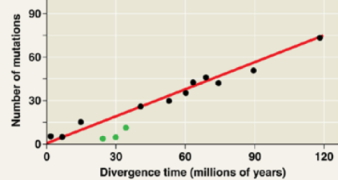
What genetic process plays a
large role in changing species?

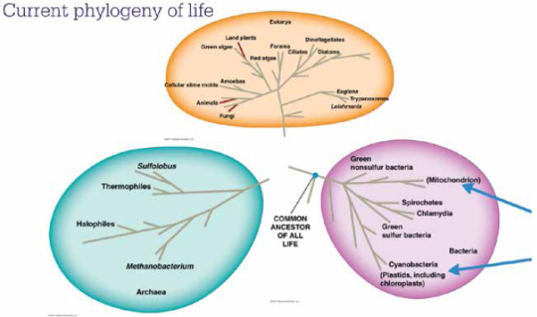
CLADISTICS:
What is a cladogram?
Steps in making a cladogram:
1.
2.
What are assumptions are
built into the process?
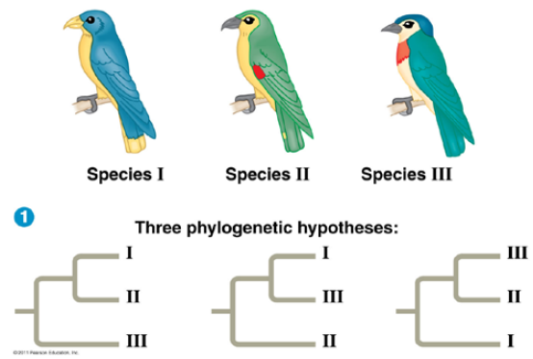
Maximum Parsimony

Maximum Likelihood

Which cladogram is best based
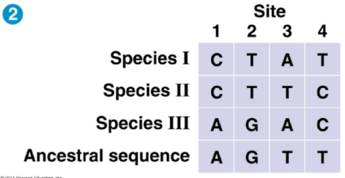
on morphology?

Based on comparison of DNA
sequences?

Types of groups / clades:
Monophyletic
Paraphyletic
Polyphyletic

Major goal of Phylogeny?

