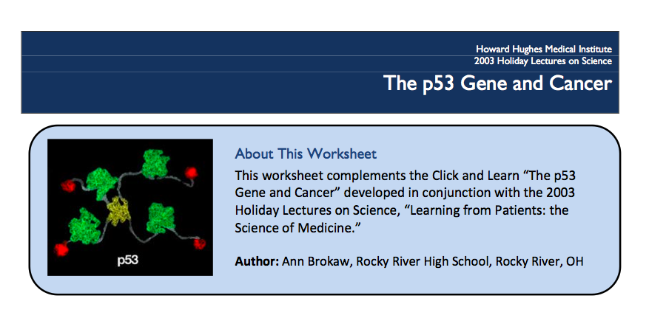

- On slide 1, “p53” is referred to as a molecule, a protein, and a gene; it is also referred to as being mutated. In your own words, and based on your knowledge of molecular genetics, how are these terms related?
- Define the following terms:
  - Oncogene: __________________________________________________________________________________________________________________________________
  - Tumor suppressor gene: __________________________________________________________________________________________________________________________________
  - DNA repair gene: __________________________________________________________________________________________________________________________________

- Based on the information on slide 2, how is p53 related to oncogenes and tumor suppressor genes?
- After watching the video clip…
  - How is a mutated oncogene analogous to a 100-pound weight on the gas pedal in a car?
__________________________________________________________________________________________________________________________________
  - How does the car analogy apply to a mutated tumor suppressor gene?
__________________________________________________________________________________________________________________________________
  - What is required for a cell to “spin out of control”?
__________________________________________________________________________________________________________________________________

- What three conditions or factors activate p53 to shut down cell division?
- Why is p53 called “guardian of the genome”?

