DNA Replication:

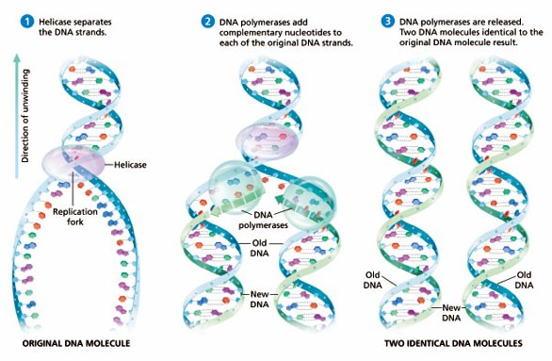1. DNA replicates during _________ of ____________.

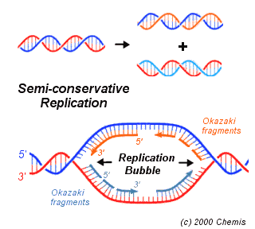2. The strand of DNA is first ___________

by the enzyme called, _________________.

3. The point of separation is called the

____________________ ________.



4. The 2nd enzyme, ______________ primes the DNA for replication.

5. These partial fragments are called _______________ ________________.

6. DNA ____________________ is the name of the enzyme that moves

along the open chains making new complimentary __________________.

7. The final enzyme, ______________, “______” behind and reforms

the _____________ and ____________ backbone.

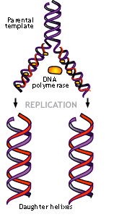

8. Now there are ________ strands.

9. Each _______________ ________ is identical to the

original strand.

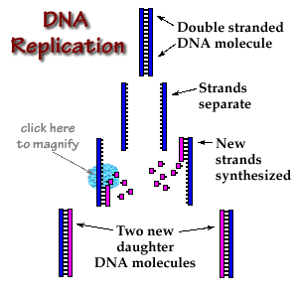

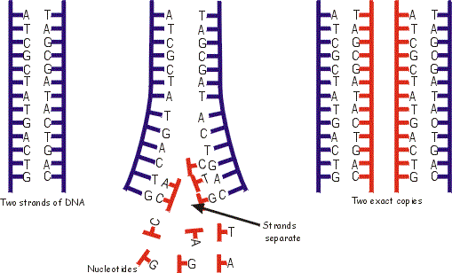

Let’s Practice!

Add the complimentary base pairs and replicate the strand of DNA making a new base sequence.