Name: _______________

DNA Notes

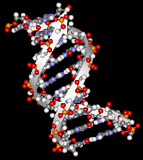
1. DNA is made up of monomers called
_____________________.

2. There are only _______ different
nucleotides.

- These same nucleotides are ___________
over and over.

4. A DNA __________________ has three
A.
parts. Label the monomer.
B.

C.

Label the picture below.
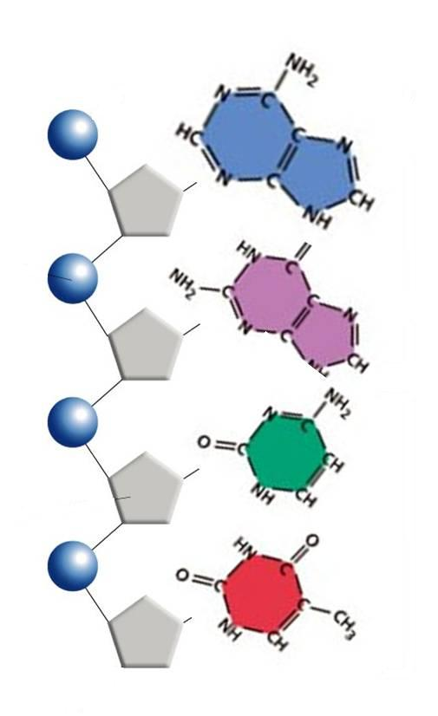

5. The purines
(Adenine and Guanine) have ______ rings of nitrogen base.

6. The pyrimidines
(Thymine and Cytosine) have only ______ ring of nitrogen base.

7. Label the picture below:
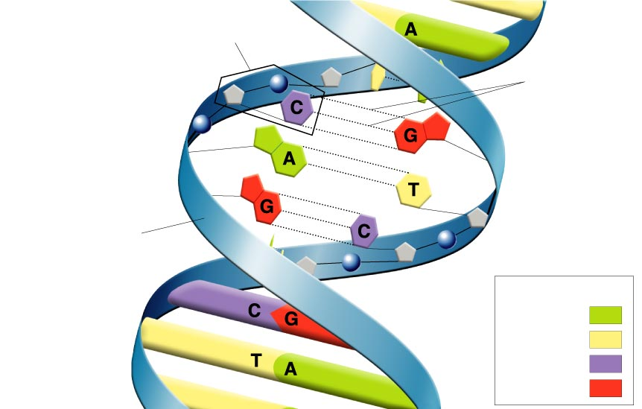

8. Nucleotides line up in pairs to form a structure that looks like a __________.

9. The ___________ and ____________ groups make up the _________ of the ladder.

10. The _________________ make up the _______ of the ladder.

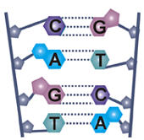
11. Cytosine bonds with _______________.

12. Adenine bonds with _______________.

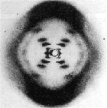
13. _____________________________
and Maurice Wilkins took the first __________
photographs of DNA.

14. The structure of DNA is known as the ________________________

