Name: ____________________
Gene Expression Notes

Genetic Engineering uses DNA 1.
Technology for purposes like:

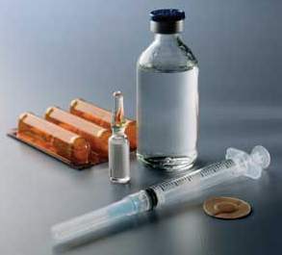

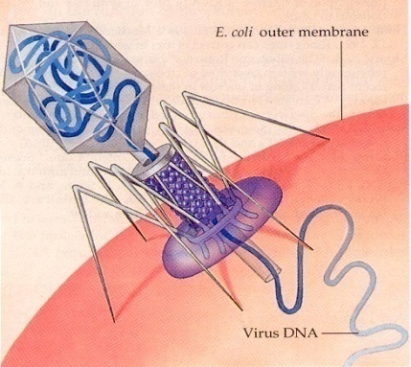
What is a Bacteria cell’s natural 2.
defense against a virus?

What is unique about each 3.
Restriction Enzyme?

Why are “sticky ends” important? 4.

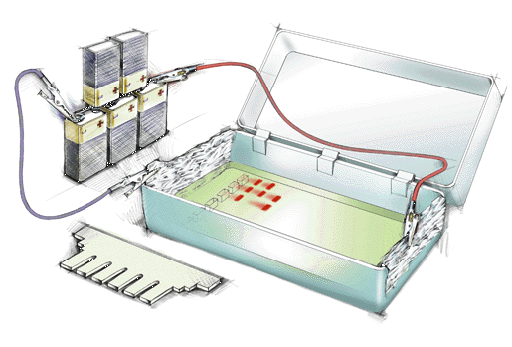
Everyone is said to have their 5.
own unique DNA Fingerprint.
In order to solve a crime, DNA
can be sorted by size through
the process known as:

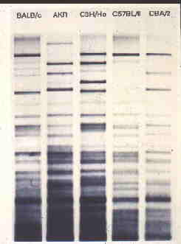

Before being loaded into a gel, 6.
the DNA must first be…

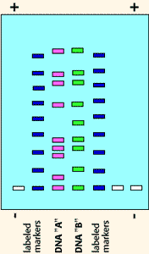
Crime Scene DNA
A
B
C

What must be done to each 7.
suspect's DNA in order to get
reliable results?

Uses for Recombinant DNA 8.
Technology include:

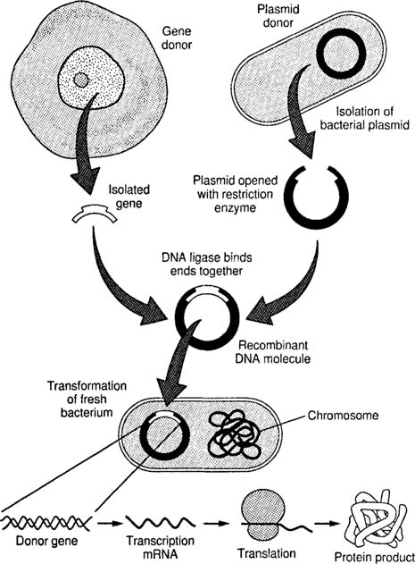
Before the pGlo lab, what did 9.
researchers have to do to both
the GFP gene and the plasmid?
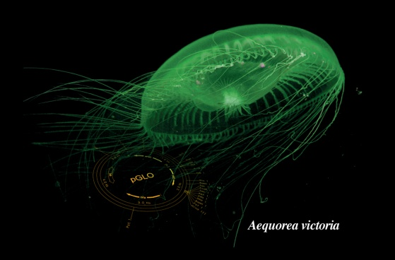

How were the plasmids 10.
“Genetically Engineered”?

Explain what actually glowed
during the pGlo lab:
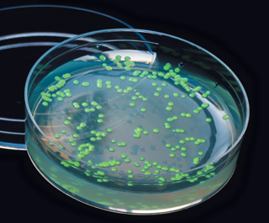
11.

Why didn’t bacteria grown 12.
without sugar glow?

No Sugar
Sugar

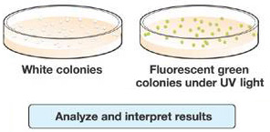

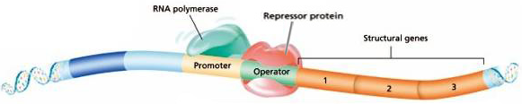

What is Gene Expression? 13.
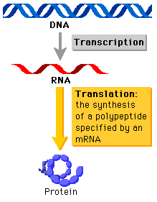

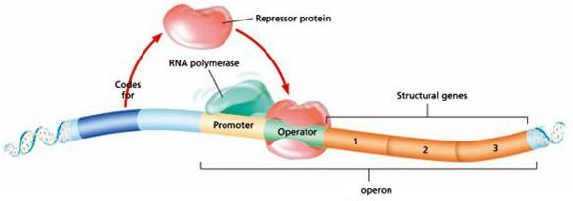

How does a repressor protein
“Turn Off” a gene? 14.

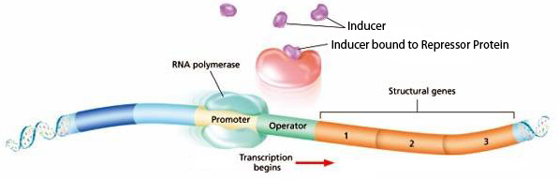

How does an inducer molecule 15.
turn a gene “On”?

Explain how Sugar was the 16.
Inducer in the pGlo lab:

No Sugar
Sugar

