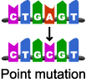
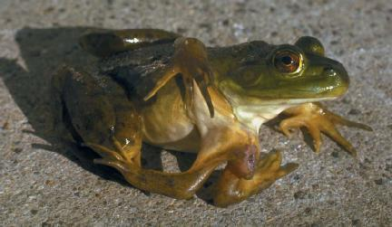
What is a Mutation?

Point mutations

Missense mutations

Nonsense mutations

Silent mutations

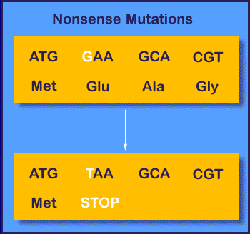
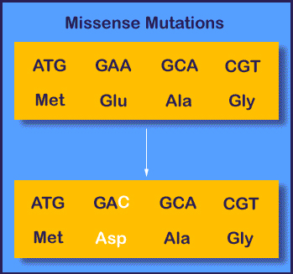

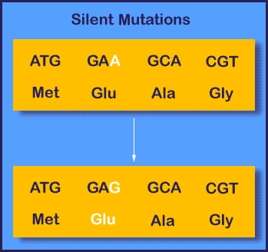
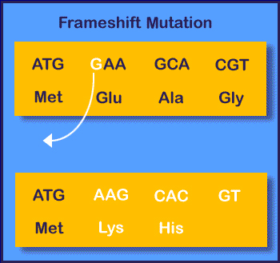

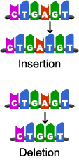
Insertion and
deletion mutations

Mutation Rate

Radiation
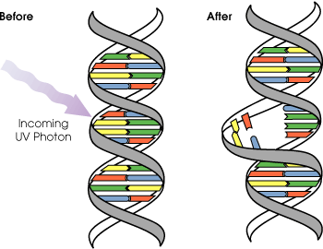

Chemicals

DNA: _________________________________________________
mRNA: _______________________________________________
AA: _________________________________________________

Practice Sentence (protein)

DNA: _________________________________________________
mRNA: _______________________________________________
AA: _________________________________________________

Insert a point mutation
(missense)

DNA: _________________________________________________
mRNA: _______________________________________________
AA: _________________________________________________

Change one letter to represent
a silent point mutation.

Eliminate one nucleotide to
DNA: _________________________________________________
mRNA: _______________________________________________
AA: _________________________________________________

cause a frameshift mutation
(take out one of the letters)

