Definition

Distinguish between random
and non-random causes

Why are small populations
more vulnerable?

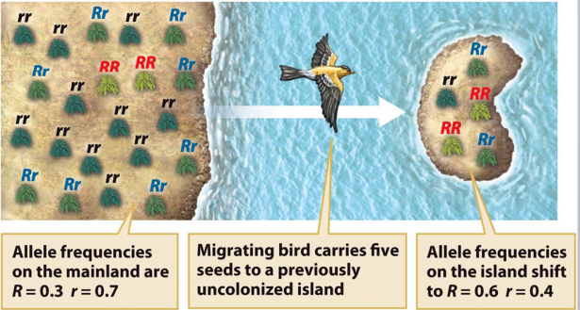

Founder effect

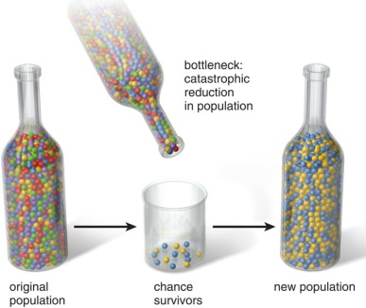

Bottleneck effect

Your scenario:

Use this space and back to plan out your experiment!

