Name: ___________________

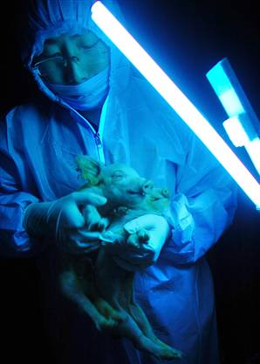
Green pig gives birth to glowing piglets

China sees results as progress toward growing organs for human transplant
The Associated Press updated 2:58 p.m. CT, Wed., Jan. 9, 2008

BEIJING - A cloned pig whose genes were altered to make it glow fluorescent green has passed on the trait to its young, a development that could lead to the future breeding of pigs for human transplant organs, a Chinese university reported.
The glowing piglets’ birth proves transgenic pigs are fertile and able to pass on their engineered traits to their offspring, according to Liu Zhonghua, a professor overseeing the breeding program at Northeast Agricultural University.
“Continued development of this technology can be applied to ... the production of special pigs for the production of human organs for transplant,” Liu said in a news release posted Tuesday on the university’s Web site.
Calls to the university seeking comment Wednesday were not answered.
The piglets’ mother was one of three pigs born with the trait in December 2006 after pig embryos were injected with fluorescent green protein. Two of the 11 piglets glow fluorescent green from their snout, trotters, and tongue under ultraviolet light, the university said.
Robin Lovell-Badge, a genetics expert at Britain’s National Institute for Medical Research, said the technology “to genetically manipulate pigs in this way would be very valuable.”
Lovell-Badge had not seen the research from China’s cloned pigs and could not comment on its credibility. He said, however, that organs from genetically altered pigs would potentially solve some of the problems of rejected organs in transplant operations.
He said the presence of the green protein would allow genetically modified cells to be tracked if they were transplanted into a human. The fact that the pig’s offspring also appeared to have the green genes would indicate that the genetic modification had successfully penetrated every cell, Lovell-Badge added.
But he said much more research and further trials — both in animals and in humans — would be necessary before the benefits of the technology could be seen.
Other genetically modified pigs have been created before, including by Scotland’s Roslin Institute, but few results have been published.
Tokyo’s Meiji University last year successfully cloned a transgenic pig that carries the genes for human diabetes, while South Korean scientists cloned cats that glow red when exposed to ultraviolet rays.
© 2008 The Associated Press. All rights reserved. This material may not be published, broadcast, rewritten or redistributed.
URL: http://www.msnbc.msn.com/id/22563650/

1. Explain how DNA can be spliced together even if it comes from two different species:
(Hint: “Restriction Enzyme” should be in your answer)

2. What is the difference between making a newborn baby pig glow compared to a 16 year old pig? Why can’t you make an older pig glow?

3. Sure, glowing in the dark is pretty cool, but how might this technology be used to cure horrible diseases like cancer? Think about the BRCA gene and what can happen if it mutates.

