Name: ____________________

Going Over Lab 4.1 pGlo Bacteria Transformation & Recombinant DNA

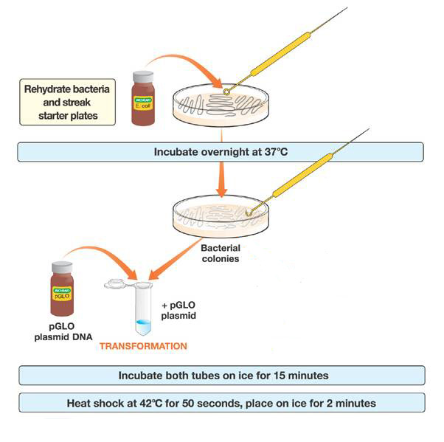
Summarize what we did on each of the days of the lab:
Previous to lab (teacher prep):

Lab Day:

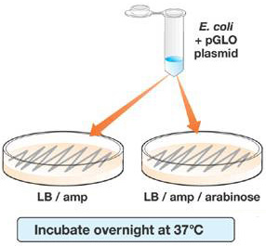

1. The GFP (Glow Fluourescence Protein) gene had already been spliced into the bacterial plasmid. Explain how we inserted the plasmid into the bacteria on lab day:

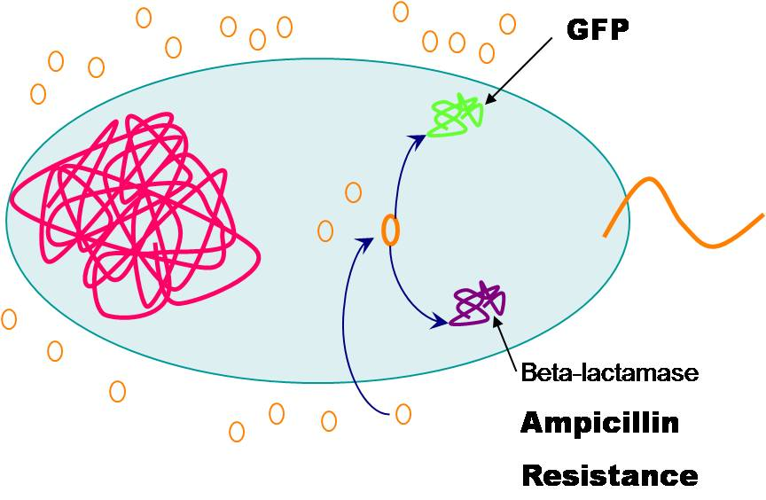

Summarize:
Day 2 - Analysis:

No Sugar
Sugar
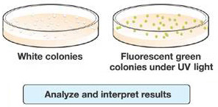

2. Explain what actually glows?
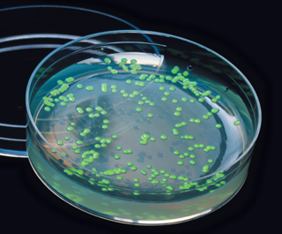

3. Bacteria grew on each of the new plates, and all of the bacteria had the plasmid inserted, so why didn’t the bacteria grown on the plate without sugar added glow? Inversely, why did the plate with sugar added allow for the bacteria to glow?

Explain how the GFP gene could be expressed or not expressed?

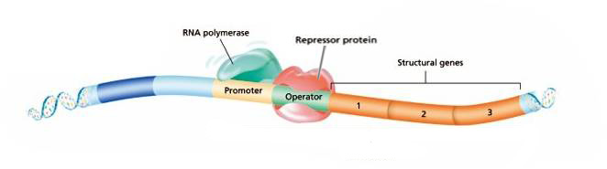

GFP Gene

