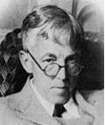
- What does the
H-W equation predict?

- What happens to genotype ratios
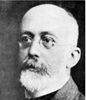
in a population over time
(under certain conditions)?

- What do the two
equations calculate?

- What is equation #1?

- What do the variables stand for?

- What is equation #2?

- What do the variables stand for?

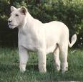
Sample Problem
- In lions the allele for the albino trait is recessive over the normal tawny-striped coloration. A sample of 100 wild lions was examined, and it was determined that 9 of these lions were white (aa). How many lions in this population would you expect to be heterozygous for the albino trait? How many homozygous and tawny colored?

Under what conditions will the HW equation not work?

Are the 5 assumptions valid? Why do we bother?

