Name: ____________________

HeLa Cells, where do you stand?
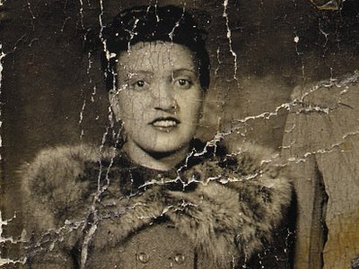
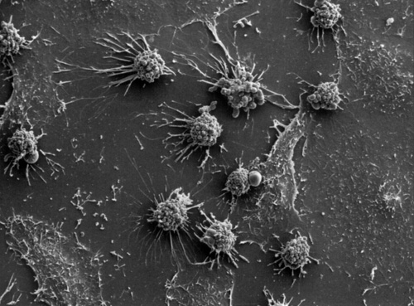

Does the Family have a Right to Compensation? Explain.
Do the Researchers have a Right to develop cures? Explain.
Do the Patients have the right at a chance of a cure? Explain.

Who do you think “owns” Henrietta’s cells? (Family, Researchers, the general public) Explain:

