How long have ideas about
evolution been around?

What is Catastrophism?

What is Gradualism?

What is Uniformitarianism?

What was the result of early theories?

Who was Lamark and what did he contribute?

What about Thomas Malthus?

Where else did Darwin get his ideas?

What about Alfred Wallace?

What is “Descent with Modification”?

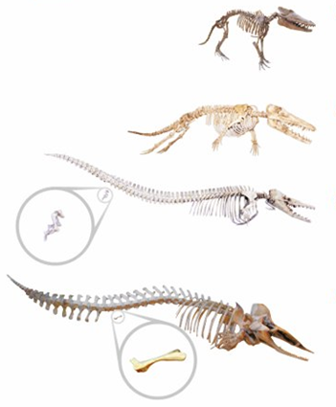

What types of evidence
are there for evolution?

What does the fossil record show us?

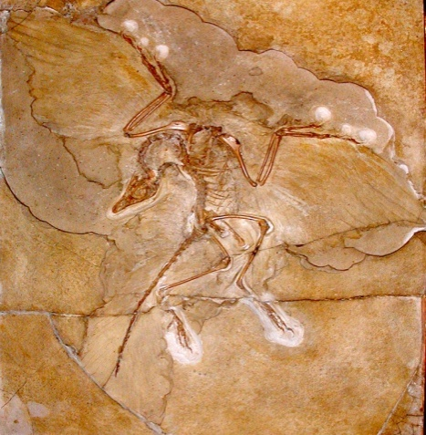
What does the distribution
of fossils show us?

What are transitional species?

What do transitional
species show us?

What is biogeography?

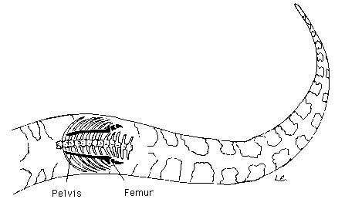

What about anatomy and physiology?

What would you expect about
the development of embryos
between closely related species?

How do biological molecules
show that all life is related?

