Introduction to pGLO
Tomorrow we will be completing a genetic transformation of pGLO. In order to be successful in lab, we need to understand the procedure and why it is important!
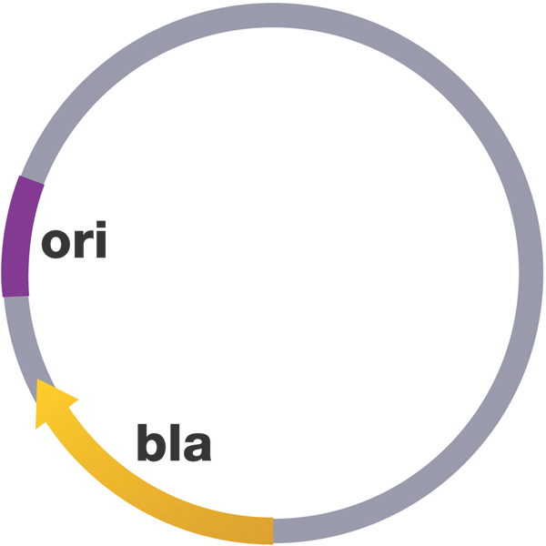
What is a plasmid?

- Provides beneficial Genes such as _______________________
- Useful for DNA technology: splice in gene of interest, put back into bacteria to grow…VOILA…lots of copies of the gene!

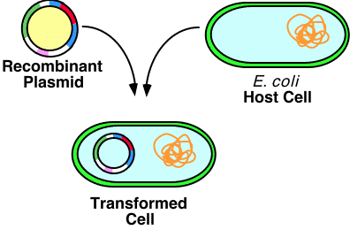
What is the gene of interest for this lab?

Where does the gene come from?

What are we going to do in lab tomorrow?

We are going to put the ___________________ plasmid into _______ bacteria!

Why is the GFP so cool?!

SPLICING DNA

First, the pGLO plasmid and the GFP gene (from the jellyfish) had to be cut by the same _____________________. This produced ___________________.

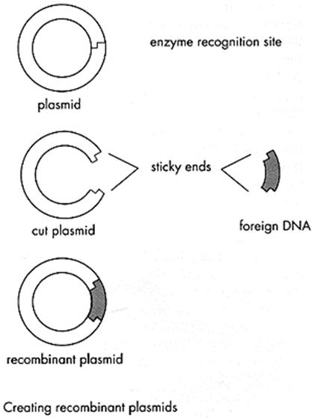
Second, the sticky ends of the isolated GFP gene and plasmid were matched up. Now it is a recombinant plasmid

Recombinant

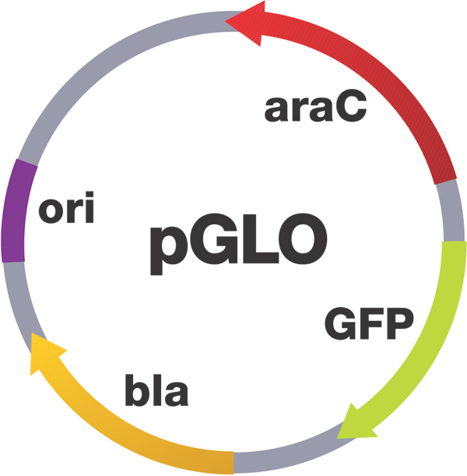
KNOWN GENES ON pGLO PLASMID

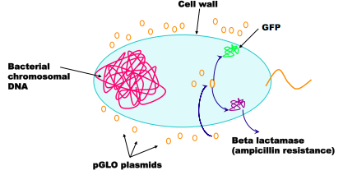
The Goal of Bacterial Transformation

What do we need to make Bacterial Transformation Successful?

Transformation Procedure
  ➔     ➔ 

Cell membrane becomes _______________ - plasmid can “sneak in through holes

Calcium Chloride | Heat Shock
- Suspend E. coli starter culture in Transformation solution (CaCl₂)
- Add pGLO plasmid DNA
- Place tubes in ice
- Heat-shock at 42°C and place on ice
- Incubate with nutrient broth
- Streak plates
- Grow overnight in incubator

