Name: _________________
Lab 4.1

Genetic Transformation: pGLO

Background Information

In this lab, you will perform a procedure known as genetic transformation. Genetic transformation occurs when a cell takes up and expresses a new piece of genetic material – DNA. This new DNA often provides the organism with a new trait, which is identifiable after transformation. Genetic transformation literally means change caused by genes, and involves the insertion of one or more gene(s) into an organism in order to change the organism’s traits.
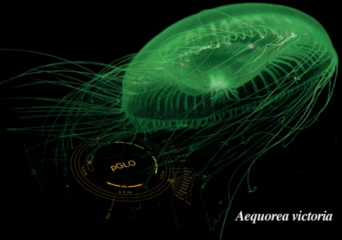
Genetic transformation is used in many areas of biotechnology. In agriculture, genes coding for traits such as frost, pest, or drought resistance can be genetically transformed into plants. In bioremediation, bacteria can be genetically transformed with genes enabling them to digest oil spills. In medicine, diseases caused by defective genes are beginning to be treated by gene therapy; that is, by genetically transforming a sick person’s cells with healthy copies of the defective gene that causes their disease.
Genes can be cut out of human, animal, or plant DNA and placed inside bacteria. For example, a healthy human gene for the hormone insulin can be put into bacteria. Under the right conditions, these bacteria can make authentic human insulin. This insulin can then be used to treat patients with the genetic disease, diabetes, because their insulin genes do not function normally.
In this lab, the pGlo transformation kit uses a simple procedure to transform bacteria with a gene that codes for Green Fluourescent Protein (GFP). The real-life source of this gene is the bioluminescent jellyfish Aequorea victoria, and GFP causes the jellyfish to fluoresce and glow in the dark. Following the transformation procedure, the bacteria express their newly acquired jellyfish gene and produce the fluorescent protein, which causes them to glow a brilliant green color under ultraviolet light.
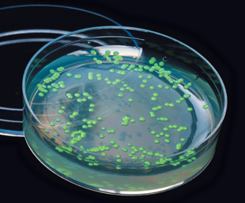
The host organism in this kit is an E. coli K-12 strain; this is not the pathogenic organism like the E. coli O157:H7 strain that has been in the news. In this activity you will learn about the process of moving genes from one organism to another with the aid of plasmid. In addition to one large chromosome, bacteria naturally contain one or more small circular pieces of DNA called plasmids. Plasmid DNA usually contains genes for one or more traits that may be beneficial to bacterial survival. In nature, bacteria can transfer plasmids back and forth, allowing them to share these beneficial genes. This natural mechanism allows bacteria to adapt to new environments. The recent occurrence of bacterial resistance to antibiotics is due to the transmission of plasmids.

1. What is genetic transformation?

2. How is genetic transformation used in the areas of agriculture and medicine?

3. What will be our “host” organism?

4. What gene sequence will we be inserting into the bacteria? Where did it come from?

5. What is a plasmid? How do bacteria naturally use them?

6. What actually glows inside the bacteria?

Part 1 (Day 1): Inserting Plasmid Carrying GFP Sequence

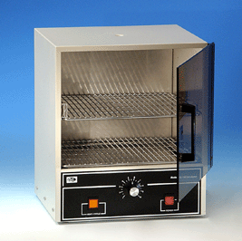
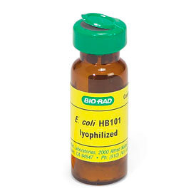
7. Starter cultures of LB Broth and a school-safe strain of E. coli bacteria have been growing in an incubator (set at about 37°C) over the past few days. The LB Broth (named after Luria and Bertani) is a nutrient-rich medium used to grow bacteria.
Incubate at 37°C for 48 hours
LB Broth
Lyophilized (freeze-dried) E. coli
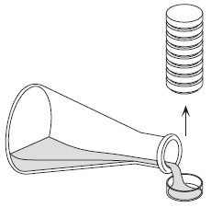
8. In addition to growing the E. coli in culture, agar plates containing the antibiotic ampicillin have been prepared in advance. The agar contains nutrients to enhance bacterial growth. However, the ampicillin will kill any bacteria that do not have the gene for antibiotic resistance. This is important for our experiment with the recombinant plasmid. Lastly, one of plates has the sugar arabinose added, and the other plate does not.
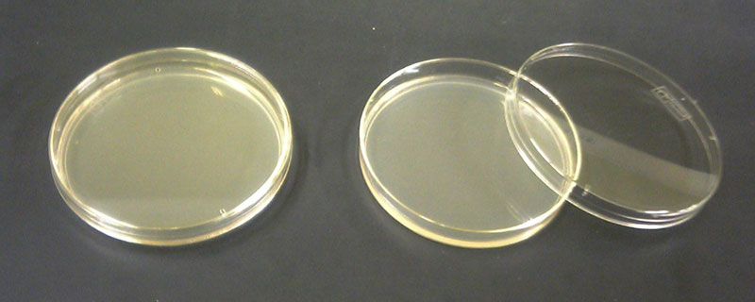

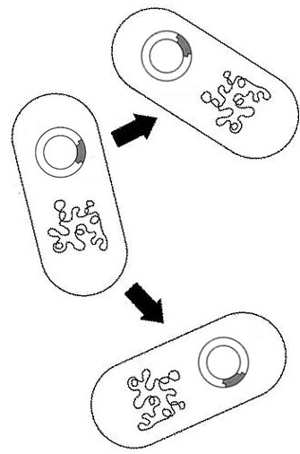
9. Your teacher has the test tube of E. coli grown in LB Broth that you will share with your classmates. Next, begin the steps of the transformation below. Remember that the GFP sequence has already been recombined into a plasmid as engineered by Maxygen, Inc. Today’s task is to insert the plasmid into the live bacteria culture.

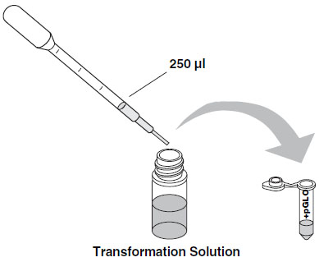
*10. The procedure used to increase the bacterial uptake of foreign DNA is called “heat shock.” Cooling down and then quickly heating up the bacteria (heat shock) increases the permeability of the cell membrane to DNA. While the mechanism is not known, the duration of the heat shock is critical and has been optimized for the type of bacteria used and the transformation conditions employed. It is important that you follow the directions regarding time in order to provide a rapid temperature change. For optimal results, the tubes containing the cell suspensions must be taken directly from ice, placed into the hot water bath set at 42°C for 50 seconds and then returned immediately to the ice.

Heat Shock Procedure:

Step 1: Attain a 1.5 µl microtube containing 250 µl of transformation fluid (CaCl₂)
that has been sitting on ice.

Step 2: Your teacher will dispense 5 µl of the E. coli bacteria from the starter culture into your microtube of transformation solution. Gently flick the microtube to mix the bacteria and transformation solution.
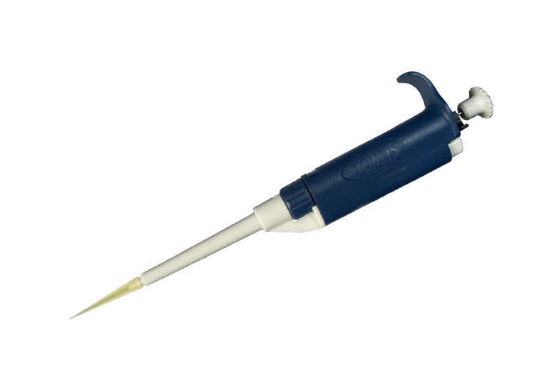
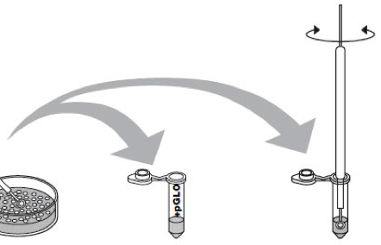

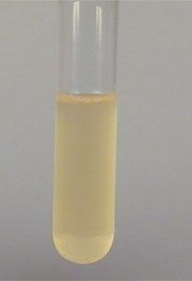

Step 3: Immerse a new sterile loop into the microtube containing the recombined plasmid DNA.
Withdraw a loopful. There should be a film of plasmid solution across the ring similar to seeing
a soapy film across a ring for blowing soap bubbles. Mix the loopful in the microtube
containing the bacteria colony you made in step 2.

Incubate the microtube containing bacteria and plasmid DNA on ice for 10 minutes.
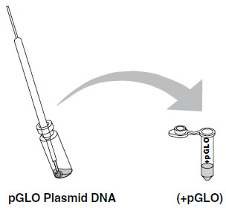

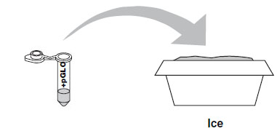

Step 4: While the tube is sitting on ice, attain two agar plates, label them with your group members’ names and class period ON THE BOTTOM, and review the next steps.
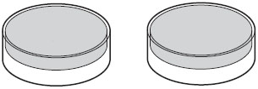
+ Sugar
- Sugar

Step 5: Heat Shock. Transfer the microtube containing the bacteria and the plasmid from the ice
directly to the hot water bath set at 42°C, for exactly 50 seconds. Have a timer
ready before you make the transfer. When the 50 seconds are done, place the tube back on
ice immediately.

Note: This is the most critical step. Timing is everything!

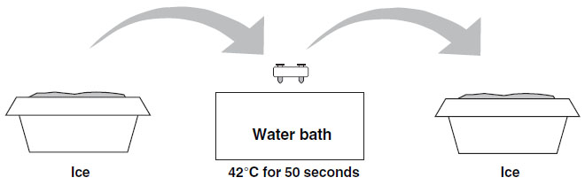

Step 6: Remove the tube from the ice and using a new sterile pipet, add 250 µl of LB nutrient broth.
Recap and tap the closed tube with your finger to mix the transformed bacteria with nutrient
broth. Then, using a transfer pipette, dispense half of the contents of the tube into each of your two plates (+sugar/-sugar). Use a new inoculating loop to evenly spread the contents over the surface of the plate. Return your plates to the incubator set at 37°C overnight.
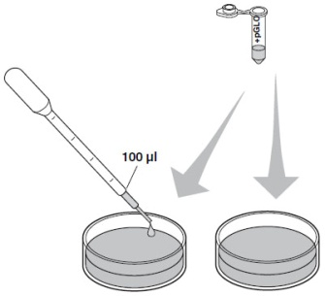
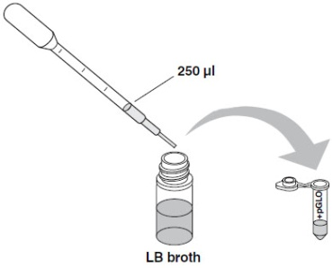
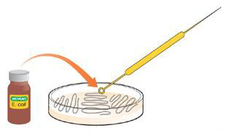
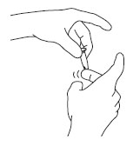

+ Sugar
- Sugar

Part 2 (Day 2): Glowing Bacteria!?!?

11. Which of the two plates contain colonies of bacteria? Record the numbers of colonies below:
+ Sugar
- Sugar

12. Obtain a UV light and shine it on your plate. Which of the two plates contains colonies of GLOWING bacteria? Explain your results:

*13. Explain why the bacteria glow under UV light?
(Underline: GFP gene, plasmid, and GFP protein in your answer.)

*14. What happened to the bacteria cultured on the “- Sugar” plate? You made both plates from the same microtube containing transformed bacteria, so why don’t both plates glow?

Before you answer, think about the phrase “Gene Expression”. For example, think about how you have always had the information in your DNA to grow armpit hair, yet you didn’t begin to grow armpit hair until around middle school age. Is it possible to have a certain gene in your DNA but never have it expressed? How could this occur? What does this mean?

