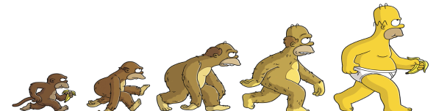
Making of the Fittest: Concepts of Evolution
Name:

Evolution Def:

Mutations Def:

Mutation Rate-

Molecular Def:
Clocks

Natural Def:
Selection

4 stages-

Adaptation Def:

Examples-

Genetic Def:
Divergence

Speciation-

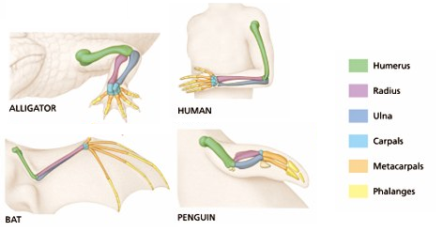
Homologous Structures-

Describe Descent with Modification:
Making of the Fittest: Concepts of Evolution (cont.)
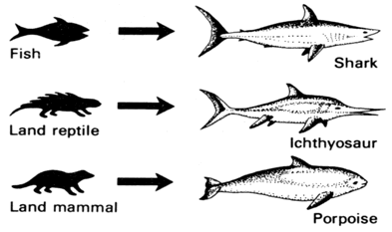
Convergent Def:
Evolution

Analogous Structures-

What is the difference between convergence and divergence?

Vestigial Def:
Structures

Examples-

Coevolution Def:

Example-

Immortal Def:
Genes

DNA as Explain:
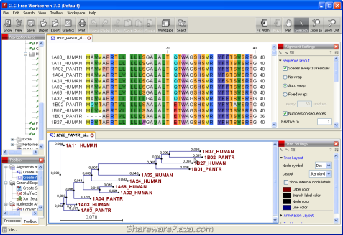
Evolutionary
Evidence

