Microscope Lab: Observing Prepared Specimens
Name __________________________________________

Objective: Use a compound light microscope to observe and draw different types of cells, both prokaryotes and eukaryotes.

Background Information: Sometimes distinguishing one cell from another requires the use of dyes or stains that highlight various structural features of the organism. Some of the prepared slides you look at will contain dyes to help you see their structures. Many stains color particular types of cells, while leaving others alone. Each specimen is dyed slightly differently.

Eyepiece = 10X magnification
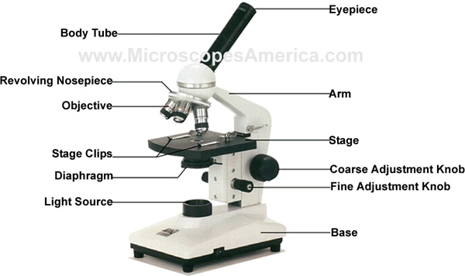

Low power (red) = 4X

Medium power (yellow) = 10X

High power (blue) = 40X

Total Magnification = Eyepiece x Objective Lens

Working in a group of 2-3, you will observe various prepared slides set up around the classroom, draw what you see, label the visible cell parts, then answer the analysis questions.

Procedure:

- Pick one of the microscopes and focus in on one cell. The microscopes have already been set up so that you do not need to adjust anything. If you need to refocus, use the fine adjustment knob. Try to keep both eyes open while looking into the microscope.

- Note the specimen’s name, magnification, sketch one cell from the field of view, and label any visible cell parts in the space provided.
  - Cell parts you MAY be able to see: cytoplasm, cell membrane, cell wall, nucleus, flagellum, chromosomes, chloroplasts, vacuole

- After all people in your group have seen the specimen (EVERYONE MUST TAKE A TURN VIEWING!), rotate to the next station. Continue until you have seen SIX slides in total. One of the slides must be a prokaryote (bacterial cells).

Data:

Specimen: ___________________
Total Magnification: __________
☐ Label visible cell parts?

Specimen: ___________________
Total Magnification: __________
☐ Label visible cell parts?

Specimen: ___________________
Total Magnification: __________
☐ Label visible cell parts?

Specimen: ___________________
Total Magnification: __________
☐ Label visible cell parts?

Specimen: ___________________
Total Magnification: __________
☐ Label visible cell parts?

Specimen: ___________________
Total Magnification: __________
☐ Label visible cell parts?

Analysis:

Using your Prokaryotic and Eukaryotic Cells packet and any other resources you need, complete the two Venn diagrams below.

Prokaryotic Cells Eukaryotic Cells

Plant Cells Animal Cells

