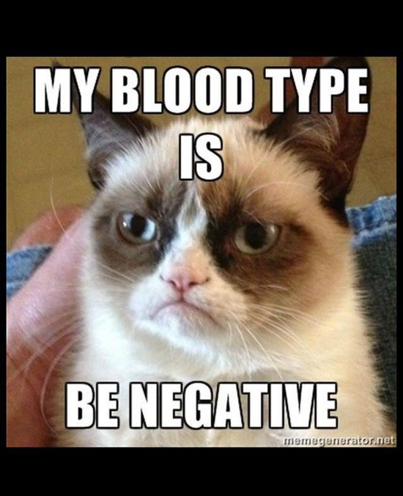
Multiple Alleles Notes
Multiple Alleles -
Antibodies –
Antigens -

Blood Type A | Blood Type B | Blood Type AB | Blood Type O
Picture  Antigen –  Antibodies –  Possible Genotypes - | Picture  Antigen –  Antibodies -  Possible Genotypes - | Picture  Antigen –  Antibodies -  Possible Genotypes - | Picture  Antigen –  Antibodies -  Possible Genotypes -

Which of the following blood type(s) is DOMINANT –
Which of the following blood type(s) is RECESSIVE -
Which of the following blood type(s) is CODOMINANT –

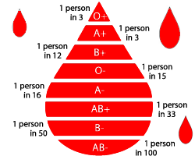
Rh Factor

+ :

- :

Multiple Alleles: Blood type is a trait that is determined by 3 different modes of inheritance: codominance, complete dominance and multiple alleles. The four possible phenotypes are of blood types A, AB, B and O. A and B alleles are codominant, while the O allele is recessive to both.

- If A is codominant with B, what offspring would be possible from a cross between two AB blood individuals? (Include the probability with which they will occur)
% Possible Genotypes:

% Possible Phenotypes:

____ A ____ B
____ AB ____ O

- A mother is Homozygous for type A and the father is Homozygous for type B. Which parent, if any can give their blood to their child in case
% Possible Genotypes:

% Possible Phenotypes:

____ A ____ B
____ AB ____ O

- Both parents have blood type A, but 3/4 of their children have blood type A and 1/4 have blood type O. What are the complete genotypes of the parents? (Hint: Fill in the Punnett Square in reverse.)
% Possible Genotypes:

% Possible Phenotypes:

____ A ____ B
____ AB ____ O

- Challenge! Show a cross between one parent who is homozygous for Type A- blood and another who is heterozygous for B+. (NOTE: blood type and the Rh factor are 2 different genes)
Possible Genotypes
____ A+ ____ AB+
____ A – ____ AB -
____ B+ ____ O+
____ B- ____ O-

