Name: _________________________________ Class: ________

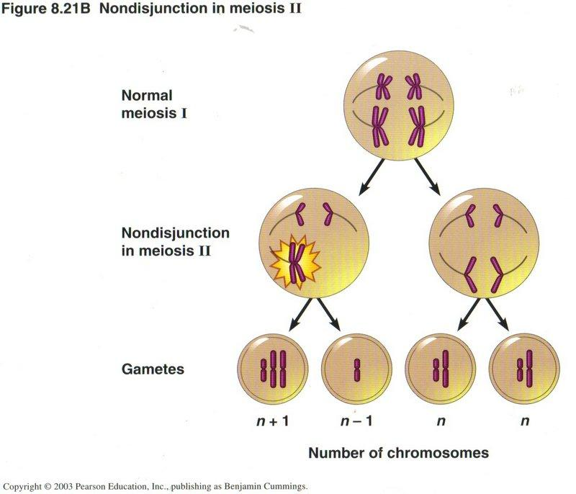
Relate your knowledge of the stages of mitosis, specifically metaphase and anaphase, to how gametes (sex cells) form via meiosis. Recall that a person can sometimes end up with extra chromosomes, like in Down syndrome (three copies of chromosome 21), or too few chromosomes, like in Turner syndrome (only one X chromosome).

- Using the diagram to the right, describe what happens if Anaphase II does not occur normally during Meiosis II. Use the terms chromosome, centromere, and spindle fibers in your answer.

- What is the name for this process when you produce gametes with too many or too few chromosomes?

Name: _________________________________ Class: ________

Relate your knowledge of the stages of mitosis, specifically metaphase and anaphase, to how gametes (sex cells) form via meiosis. Recall that a person can sometimes end up with extra chromosomes, like in Down syndrome (three copies of chromosome 21), or too few chromosomes, like in Turner syndrome (only one X chromosome).

- Using the diagram to the right, describe what happens if Anaphase II does not occur normally during Meiosis II. Use the terms chromosome, centromere, and spindle fibers in your answer.

- What is the name for this process when you produce gametes with too many or too few chromosomes?

