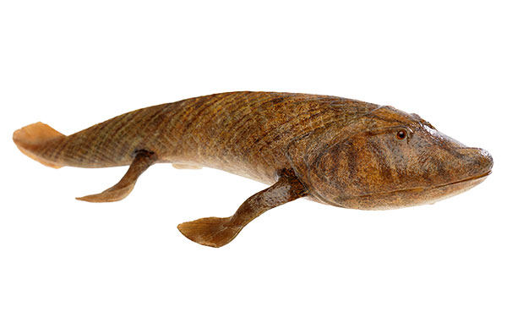
Name ________________________
Part 1 (0 – 5:00):
What are transitional fossils? Why are they important?

What evidence suggests that four-legged animals evolved from fish?

Part 2 (5:01 – 13:10):
Why did the paleontologists decide to hunt for the transitional fossil in Alaska?

Part 3 (13:11 – 17:11):
Why is Tiktaalik considered a transitional fossil?

Did the transition from fish to tetrapod happen quickly or slowly?

