Name: ______________________

How can we look for cancer genes?

Today, you will be acting as an oncologist. A biopsy revealed that the ovarian tissue for your patient (Jen) is rapidly dividing faster than normal rates of cell division for this area. The cells have been mini-prepped prior to their arrival on your lab table: her cells have been lysed, the DNA has been extracted, purified, and copied during a process called PCR (Polymerase Chain Reaction). Your task is to conduct DNA gel electrophoresis on her DNA from various cell samples taken from her body, as well as healthy tissue from other patients, to look for the presence of gene p53, a tumor suppressor gene located on Chromosome 17.
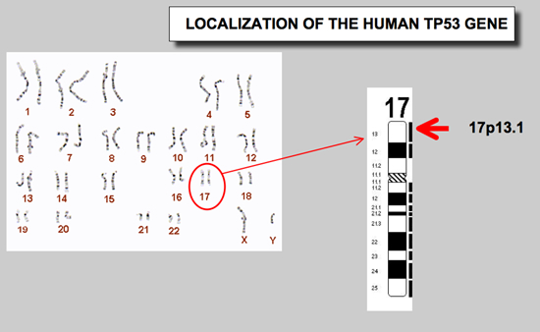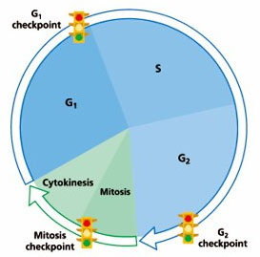

Let’s think about it…

1. Gene p53 is a tumor suppressor gene. Is this a “good gene” or a “bad gene” to have? Explain what happens to it when it is mutated

2. Explain why regulators of the cell cycle are so vital to maintaining cells’ health.

3. Where is p53 located?

Lab Protocol:

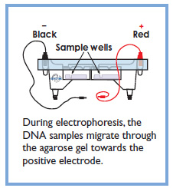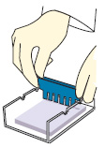
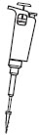
Lane |  | Contents
1 | 15μl DNA Ladder
2 | 15μl gene p53
3 | 15μl Jen’s surrounding tissue
4 | 15μl Jen’s tumor cells
5 | 15μl Normal ovarian cells

PROTOCOL

1. Insert the gel mold into the electrophoresis chamber and fill the chamber with 1x LB buffer until the gel is just barely submerged.

2. Load 15 µL each of sample into the wells as indicated by the table above.

3. Place the cover on the chamber and carefully bring it over to a power supply set to 300V for 15 minutes.

4. After the gel has run, unplug it from the power supply and carefully carry the entire chamber up to the front lab table so it can be viewed on the UV Transiluminator. Note: Dye has been loaded into your samples that is only excited by UV light

While your gels are running…

- What is the technique of DNA Gel Electrophoresis used for?

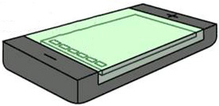2. Draw what is happening 3. What direction do the DNA fragments travel
within the gel: and WHY????

4. DNA will be sorted according to what characteristic? 5. In what units is this measured?

6. Observe the gel chamber pictures below and draw where the electrical current goes if you do and do not overfill the gel chamber with buffer? (Hint…Physics electricity concept)
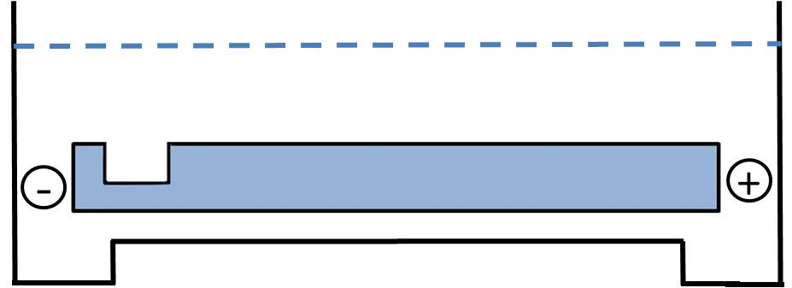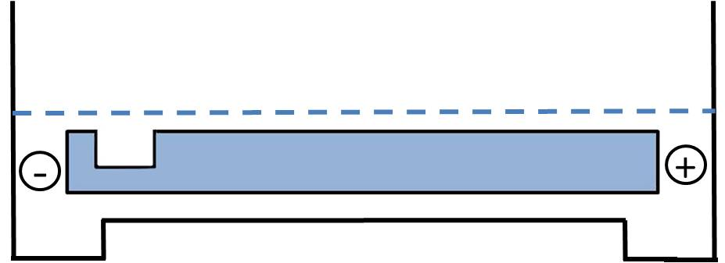

Post-Lab Analysis:

1. While observing your gel, label the wells and draw in your DNA bands on the image below:

2. Why did we run only gene p53 in lane 2?
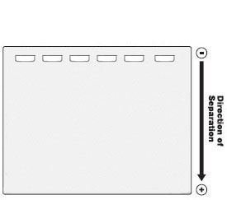

3. Why do we run a lane with healthy tissue in lanes 3 and 5?

4. Measure the distance each fragment of the DNA ladder “migrated” down the gel from the starting line and record in the table below.
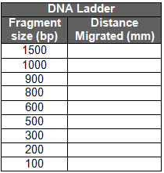
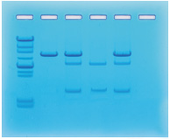

Lane |  | Contents
1 | 15μl DNA Ladder
2 | 15μl gene p53
3 | 15μl Jen’s surrounding tissue
4 | 15μl Jen’s tumor cells
5 | 15μl Normal ovarian cells

5. Plot the points and draw a best fit straight line of your DNA standards on the log graph on the next page:

Graph of DNA Ladder Standard Curve
1000
900
800
700
600
500
400
DNA Fragment Size (# of base pairs)
300

200

100
90
80
70
60
50
40
30

20

10

5 10 15 20 25 30 35 40 45 50
Distance Migrated (mm)

6. Measure the distance of migration of the known p53 gene in lane 2. Using the graph above and the data from the DNA standard, determine how long the nucleotide sequence is of p53.

