Name: ______________________
How can we look for cancer genes?

[Introduction Pre-Lab Reading]
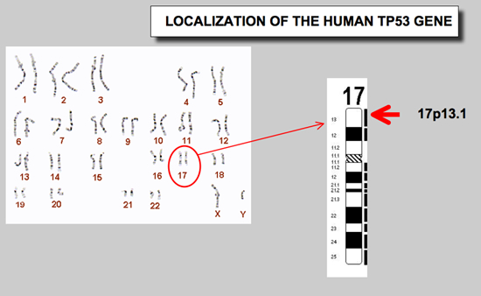
The study of inherited cancers has given cancer molecular biologists the opportunity to search for genes that are critical in normal cell development and carcinogenesis. At the molecular level, cancer formation is characterized by alterations in both proto-oncogenes and tumor suppressor genes. Tumor suppressors genes, such as p53, code for normal cellular proteins that are involved in limiting cell growth. By contrast, proto-oncogenes code for proteins that promote the growth of cells. If these genes become mutated and are unable to produce proteins that regulate a cell’s life cycle, they are called oncogenes.
In recent years, the p53 tumor suppressor protein has become the center of many cancer studies. Because it appears to be of major significance, there is great impetus to study how this gene functions in normal cells compared to cancer cells. The p53 gene that codes for this p53 protein is located on the short arm of chromosome 17. The normal p53 protein functions as a cell regulator. When mutated, p53 loses its ability to regulate cell growth and division. Additionally, the p53 gene has specific “hot spots” regions where mutations not only lose their regulatory abilities, but they also promote uncontrolled cell growth. These mutated p53 genes therefore function as oncogenes.

Let’s think about it…

1. Explain the difference between a tumor suppressor gene and an oncogene:

2. How does p53 function normally in cells and, in a way, protect you from cancer?

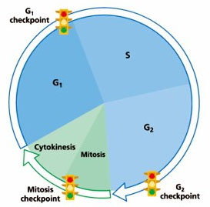
3. During a cell’s life cycle, the cell must stop at different “checkpoints” to make sure it is ready to move onto the next step in the cycle. Three different “checkpoints” are denoted on the diagram of the cell cycle below. Based on your knowledge of what occurs at each stage in the cell cycle, what do you suppose is being checked for at each of the three “checkpoints”?

a. Checkpoint before S-phase:

b. Checkpoint near end of G2:

c. Checkpoint before cytokinesis:

Tomorrow, you will be investigating the importance of the p53 gene in determining whether or not cells are deemed healthy or cancerous. We will be taking cell samples from different places in our patient’s body, as well as healthy cells from another patient, to determine whether or not p53 is present in our patient’s cells. The technique you will used is called DNA Gel Electrophoresis. The cells from each sample have been mini-prepped prior to their arrival on your lab table: her cells have been lysed, the DNA has been extracted and purified (so we only get the DNA we are targeting), and copied during a process called PCR (polymerase Chain Reaction). You will learn exactly how this process of DNA gel electrophoresis works tomorrow.

4. You are going to be running DNA gel electrophoresis on the cells listed in the table below. Indicate whether or not you think you will see the band of gene p53 or not in each of the lanes:

Lane | Tissue Sample | Will you see the band for gene p53?
3 | Jen’s tissue around her ovaries
4 | Jen’s ovarian tumor cells
5 | Normal ovarian cells

5. DNA is a negatively charged molecule because of its phosphate backbone. Will
it be attracted to a negative or positive pole?

6. DNA is a polymer, made up of many units called nucleotides. In what ways could we compare different segments of DNA:

