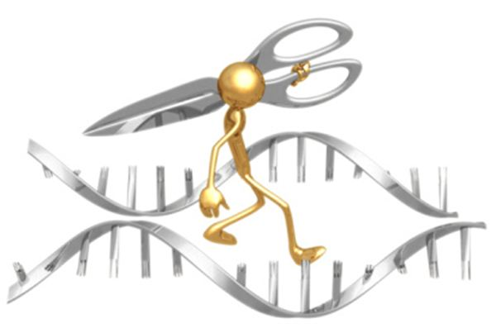
Paper Plasmid Pre-Lab Opener

You learned that restriction enzymes are like molecular scissors; they cut double-stranded DNA at specific sequences.
There are two different types of cuts restriction enzymes can make on the DNA:

- Sticky ends – there is an overhang of unpaired bases

- Blunt ends – a clean cut; all bases are paired at the ends

Given the restriction enzymes HaeIII and BamHI (shown below with their restriction sites), cut the DNA sequence below at all possible places. Draw a line between the bases where the restriction enzyme would cut.

5’ ACGTTACTAAGCGGCCATACCTGTACCAAGGATCCGGACTGCATA 3’
3’ TGCAATGATTCGCCGGTATGGACATGGTTCCTAGGCCTGACGTAT 5’

What type of end did HaeIII produce? Blunt / Sticky

What type of end did BamHI produce? Blunt / Sticky
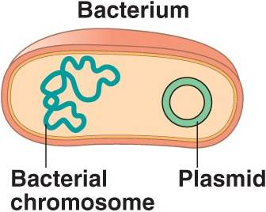
Plasmids and Vectors

Bacterial plasmids are loops of DNA found in some bacteria. They contain special genes that are not related to basic life functions, i.e., antibiotic resistance. They can be transferred from one bacterial cell to another.

In DNA technology, scientists make use of bacterial plasmids by cutting them with restriction enzymes and inserting genes of interest. You need to use the same restriction enzyme to cut the plasmid and DNA where your gene is found. Why is this important?

Knowing this information and what you are about to model in lab, please fill in the table below.

 | What is the shape? | How many times should it be cut by a restriction enzyme in order to… | If given the choice to use HaeIII or BamHI, which one would you choose and why?
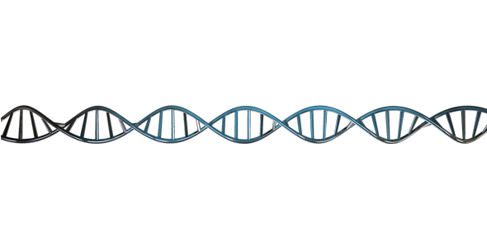  DNA w/ Gene of Interest |  | …isolate a gene in the DNA molecule?
Plasmid |  | …open the plasmid so the gene can be recombined?

