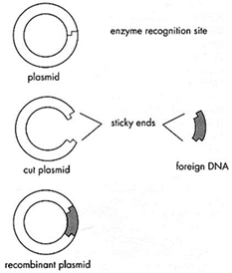
Name ___________________________

- From what two organisms did you source DNA to create a recombinant plasmid?

- What gene were we trying to insert into the plasmid? How will we be able to tell the procedure worked when we actually perform the genetic transformation in lab?

- How do restriction enzymes know where to cut the DNA?

- When the enzyme cuts DNA, why is it important that it creates “sticky ends”?

- Why is it important that the enzyme only cuts the plasmid once?

- Why is the location of the two cuts that the enzyme makes in the cell DNA so critical?

- Indicate on the following diagram where the sticky end is by circling it. Then, create a complimentary sticky end and draw it in the proper place.

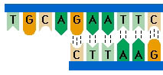

- What would happen if you chose one type of enzyme to cut the cell DNA (green) and a different enzyme to cut the plasmid (white)?

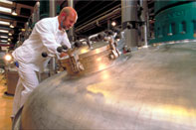
Read the following passage, answer the questions and get ready for
some cool animations!

Producing human insulin – a history

For many years, insulin was obtained by purifying it from the pancreas of cows and pigs slaughtered for food. This was expensive, difficult and the insulin could cause allergic reactions.
Once the structure of human insulin had been found, in 1955, the cow and pig insulin could be chemically modified to be the same as human insulin. It is now made by genetically-engineered microbes. They produce human insulin in a pure form that is less likely to cause allergic reactions.

Human insulin is produced in a very controlled and clean environment. Genetically-engineered bacteria are grown in large stainless steel fermentation vessels. The vessel contains all the nutrients needed for growth. When the fermentation is complete, the mixture containing the bacteria is harvested. The bacteria are filtered off and broken open to release the insulin they have produced. It is then purified and packaged into bottles for distribution. All the equipment is kept sterile so that contamination cannot get into the medicine. Regular checks make sure that all the processes are working properly and the insulin meets the required quality.

- How was insulin produced before 1955? How is it made now?

- Describe the process for making insulin using genetically-engineered bacteria.

.

