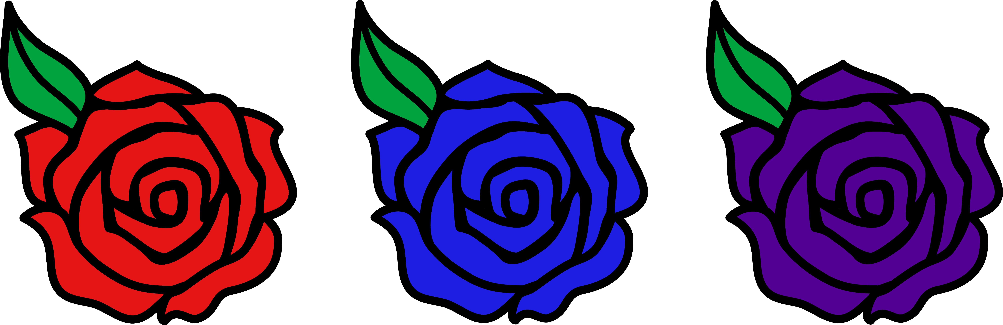
Bikini Bottom Genetics Name

Incomplete Dominance

SpongeBob loves growing flowers for his pal Sandy! Her favorite flowers, Poofkins, are found in red, blue, and purple. Use the information provided and your knowledge of incomplete dominance to complete each section below.

- Write the correct genotype for each color if R represents a red gene and B represents a blue gene.

Red -
Blue - _
Purple -

- What would happen if SpongeBob crossed a Poofkin with red flowers with a Poofkin with blue flowers? Complete the Punnett square to determine the chances of each flower color.

  - Give the genotypes and percentages for the offspring.

  - How many of the plants would have red flowers? %

  - How many of the plants would have purple flowers? %

  - How many of the plants would have blue flowers? %

- What would happen if SpongeBob crossed two Poofkins with purple flowers? Complete the Punnett square to show the probability for each flower color.

  - Give the genotypes and percentages for the offspring.

  - How many of the plants would have red flowers? %

  - How many of the plants would have purple flowers? %

  - How many of the plants would have blue flowers? %

- What would happen if SpongeBob crossed a Poofkin with purple flowers with a Poofkin with blue flowers? Complete the Punnett square to show the probability for plants with each flower color.

  - Give the genotypes and phenotypes for the offspring.

  - If SpongeBob planted 100 seeds from this cross, how many should he expect to have of each color?

Purple flowers - Blue flowers - _ Red flowers -

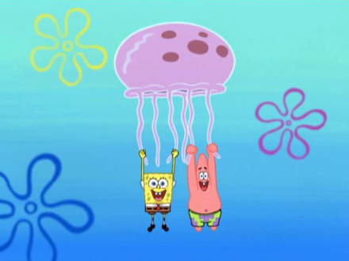
Bikini Bottom Genetics

Codominance

SpongeBob and his pal Patrick love to go jellyfishing at Jellyfish Fields! The fields are home to a special type of blue-and-yellow spotted jellyfish known as Goobers and only really great jellyfishermen are lucky enough to catch some on every trip. Many of the jellyfish are yellow (YY) or blue (BB), but some end up blue-and-yellow spotted as a result of codominance. Use this information to help you complete each section below.

- What would happen if SpongeBob and Patrick crossed two “goobers” or blue/yellow spotted jellyfish? Complete the Punnett square to help you determine the probability for each color of jellyfish.

  - Give the possible genotypes and percentages for the offspring.

  - What percentage of the offspring would be yellow? %

  - What percentage would be blue? %

  - What percentage would be “goobers” (blue/yellow spotted)? %

- What would happen if they crossed a yellow jellyfish with a goober? Complete the Punnett square to help you determine the probability for each color of jellyfish.

  - Give the possible genotypes and percentages for the offspring.

  - What percentage of the offspring would be yellow? %

  - What percentage would be blue? %

  - What percentage would be “goobers” (blue/yellow spotted)? %

- What would happen if they crossed a blue jellyfish with a yellow jellyfish? Complete the Punnett square to help you answer the questions.

If 100 jellyfish were produced from this cross, how many would you expect for each?

Yellow -
Blue -
Goobers -

- What would happen if they crossed a blue jellyfish with a goober? Complete the Punnett square to help you answer the questions.

If 100 jellyfish were produced from this cross, how many would you expect for each?

Yellow -
Blue -
Goobers -

