Directions: Use the NIH article to conduct and record research on stem cells.
Name:
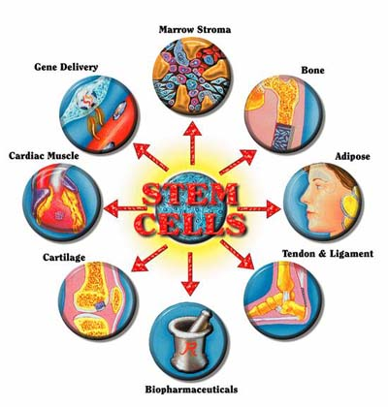
- Why is the name "Stem Cell" appropriate for these types of cells?

- What could potentially happen to the new cell when a stem cell divides?

- What happens to the inner stem cells of a young embryo?

- What are the three characteristics this article used to describe stem cells?

- Why do scientists study the self-renewal of stem cells? What can they learn from this research?

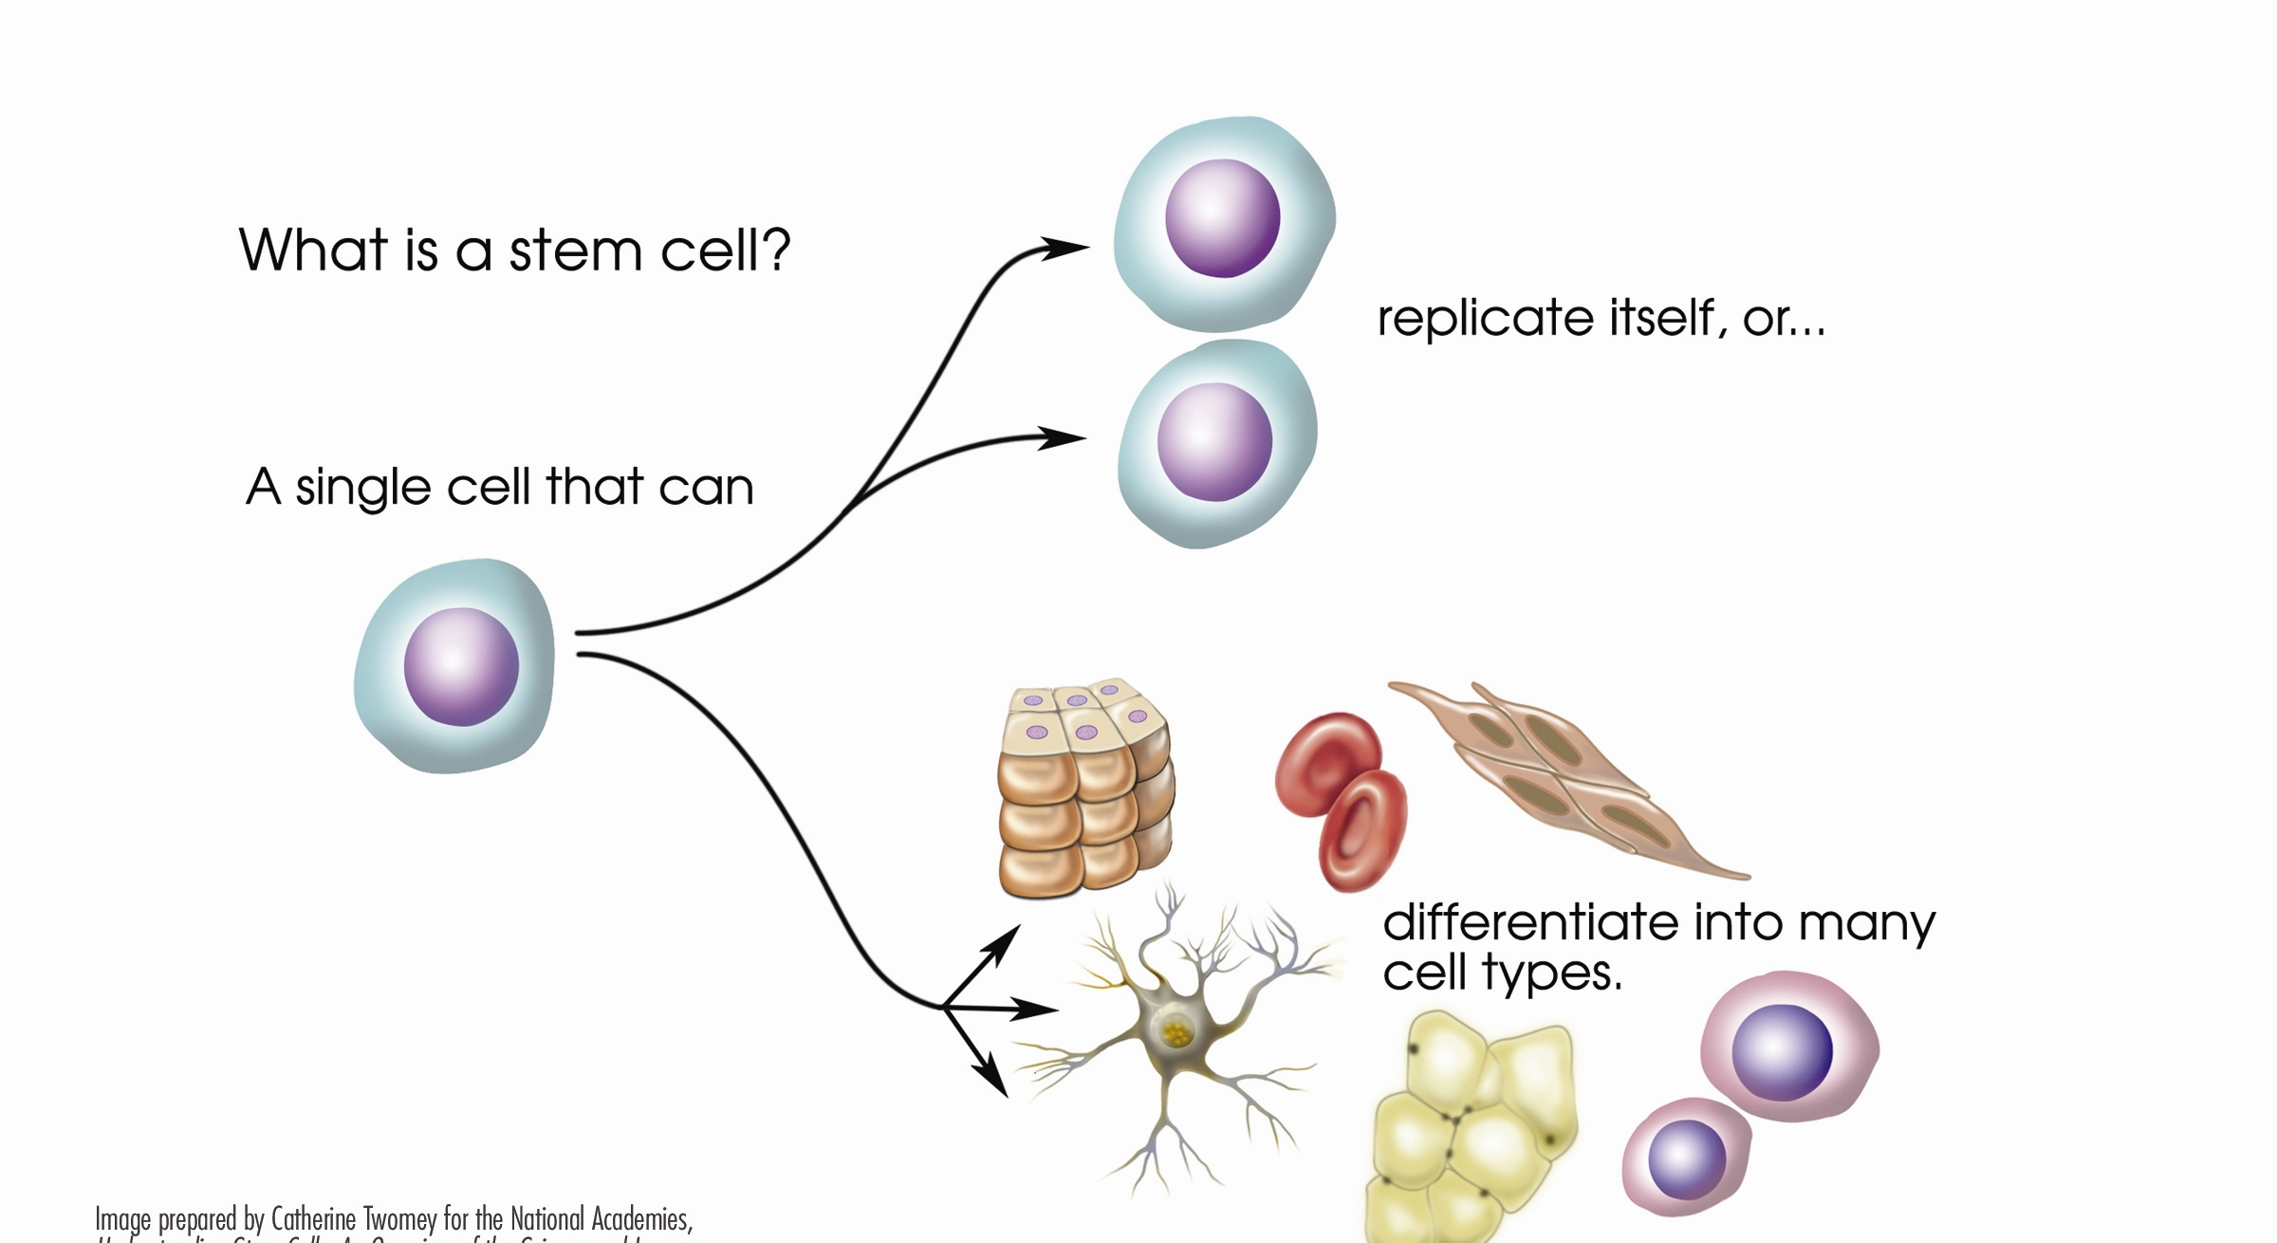
- Why are stem cells said to be unspecialized, and how is this different from somatic (body) cells?

- What does the term differentiation mean?

- Give one potential for further stem cell research.

