Strawfish and Selection Trend Opener

Under each graph, label which test(s) best matches what happened to the phenotype frequency of the strawfish during each generation compared to the control. Also label the type of selection trend: Stabilizing, Directional, or Disruptive.
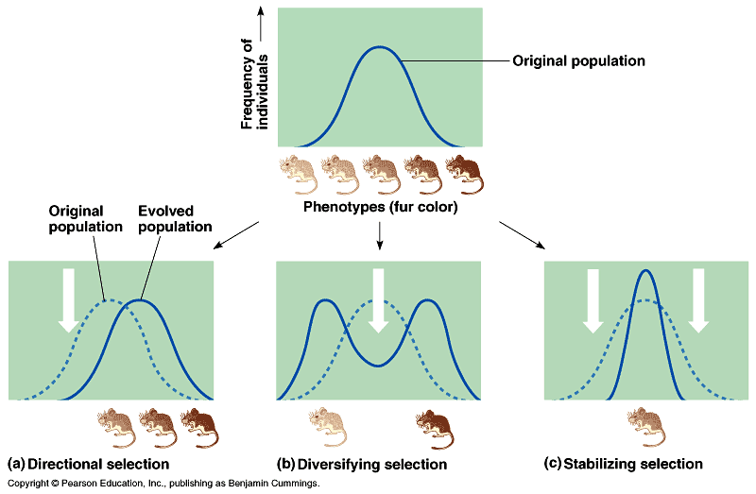
yellow green blue

Strawfish Phenotype
Test 1 – Predators prefer blue fish
Test 2 – Predators prefer yellow fish
Test 3 – Predators prefer green fish
Test 4 – Green fish are camouflaged

Strawfish and Selection Trend Opener

Under each graph, label which test(s) best matches what happened to the phenotype frequency of the strawfish during each generation compared to the control. Also label the type of selection trend: Stabilizing, Directional, or Disruptive.
yellow green blue

Strawfish Phenotype
Test 1 – Predators prefer blue fish
Test 2 – Predators prefer yellow fish
Test 3 – Predators prefer green fish
Test 4 – Green fish are camouflaged

