Name: ___________________
Switched at Birth

There has been a mix-up at the hospital and four newborn babies have “lost” their parents. Perform a simple blood test to match the unknown baby with their correct biological parents.
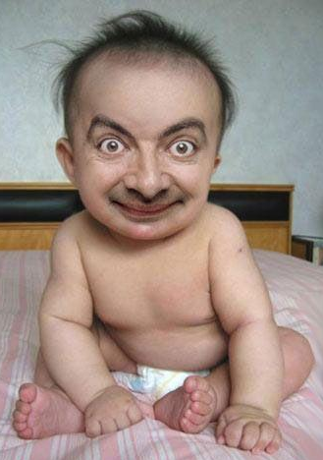

How to Perform a Blood-Typing Test:

Step 1: Apply one drop of each unknown blood type into each of the 3 wells.
Step 2: Add one drop of each of the anti-serums to each of the corresponding wells.
Step 3: View over white paper background.

1. Record the results of what you observe in the data table below:
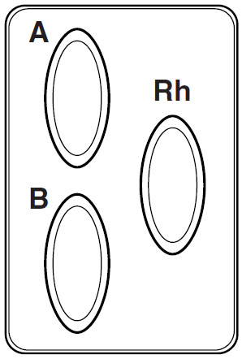
* * * Mark each box with a (+) if positive for clumping after sera are addded * * *

 | Anti-A Sera | Anti-B Sera | Anti-Rh Sera | Blood Type
Baby W
Baby X
Baby Y
Baby Z

2. Complete the punnett squares indicating the possible genotypes of the offspring of each couple below then match each baby with the correct couple. THIS IS FOR ABO BLOOD TYPING ONLY!

Hint: There are two punnett squares so that you can cross the homozygous and heterozygous genotypes that may result in either A or B type blood.

Couple #1: Couple #2: Couple #3: Couple #4:
O and AB AB and B O and O O and A

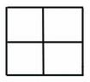

Baby: _____ Baby: _____ Baby: _____ Baby: _____

CHECKPOINT! Get your teacher’s initials here before moving on: _______________

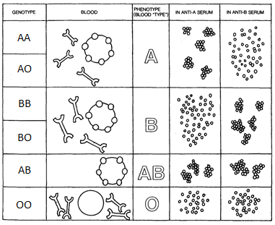

3. Complete the following analysis table below:

 | ABO Blood Type | Genotype | Antigens present on blood cells | Antibodies present in plasma | 1 parent able to donate blood (yes or no?)
Baby W
Baby X
Baby Y
Baby Z

4. When we are comparing 2 different traits, we can use 2 crosses to determine the possible outcomes. Rh factor is another trait involved in blood type. + (positive) is completely dominant to – (negative). Cross a father who is heterozygous for blood type A and also heterozygous for a + Rh factor with a mother who has O- blood. Multiply the probabilities for each outcome to fill the boxes below:

A O
Parental Genotypes
Male ________ Female ________

O

O
Possible Phenotypes
_____ A+ _____ AB+
_____ A- _____ AB-
_____ B+ _____ O+
_____ B- _____ O-
+ -
- -

