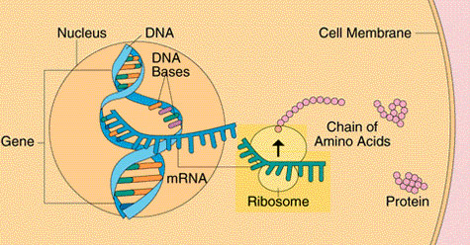
What’s a Trait?
Name: ______________________________________

Simulating Protein Synthesis – Follow Up

Phase One – Constructing the DNA

- Where is DNA is stored in the cell?

- How many strands made up your DNA molecule?

- What are the complementary base pair rules you used to construct your top and bottom stands?

- What type of bond is holding the base pairs together?

Phase Two – Transcribing the DNA (Transcription)

- Why did you have to separate the DNA strands before transcribing it?

- What important information is found in the sequence of the nitrogen bases (the rungs of the double stranded DNA ladder)?

- If you only want the information from one gene (only one chapter in the book), do you have to copy the entire DNA molecule (the entire book)? Explain.

- What was different about your mRNA strand compared to the DNA? What was the same?

- What base pair rules did you use to make the complementary mRNA strand from the bottom strand of DNA during transcription?

- Where does transcription take place?

Phase Three – Assembling the Amino Acid Sequence (Translation)

- What are the building blocks (monomers) of a protein?

- What other type of RNA molecule did you need to assemble your amino acid sequence?

- The sequence of bases within your mRNA copy gives the cell instructions on how to assemble the amino acids. What is the function of the tRNA?

- More generally, where does translation take place? More specifically, on what organelle does translation occur?

- Why did you move the DNA cards aside during this part of the activity?

- Using your knowledge from the activity, what can you conclude about how many strands RNA has compared to DNA?

- When assembling your amino acid sequence, some of your sequences may not have made sense. This was due to a tRNA carrying a “Stop” signal. Where in the sequence should this signal have been? Why?

- How did you know which tRNA molecule to choose during translation?

- This activity was used to simulate the formation of a protein. Do you think the actual sequence of a protein is made of this number of amino acids? Could the number be smaller? Larger? What do you think and why?

